

**Resource Checklist**

**By**

***Team Name – Decoders***

***Team No# 20***

Swathi Jasthi

Divya Gaddam

Mounika Prathipati

Uma Maheswara Reddy Mandapati

**COMP-SCI 5551 Adv Software Engineering**

**University of Missouri Kansas City**

**Spring – 2016**

**Contents**

**Project Goal and Objectives ........................................................................................ 2**

**Motivation .............................................................................................................. 3**

**Significance/Uniqueness ......................................................................................... 3**

**Obectives ................................................................................................................ 3**

**System Features ..................................................................................................... 4**

**First Increment Report……………………………………………………………………………………………….4**

**Existing Services/Rest API……………………………………………………………………………………...4**

**Detail Design Features…………………………………………………………………………………………...4 Testing……………………………………………………………………….…………………………………….……...10**

**Implementation……………………………………………………………………………………………..….….…10 Deployment……………………………………………………………………………………………………….…….15**

**Project Management………………………………………………………………………………………….…….15**

**Bibliography………………………………………………………………………………………………………….....16**

# Project Deployment

**Introduction:**

To keep track of all the lent items. Search and update the item details to the database. Compare prices of an item scanned from different websites. Buy the product with unbeatable price.

**How to use the system?**

**Login Page:** First,the user has to login into the application using valid credentials. If the user is not a valid registered user, he need to register by clicking on New User? Register button.

**Register Page:** If the user is new, he has to register by giving valid email address in this page. There is validation for email address, password and confirm password.

**Home Page:** After a successful login, the user is navigated to home page. Here the user had to scan the item using “scan” button. If the scan is successful, the item details are automatically populated in the fields of Item Description and Item Brand. The borrower name and his email address has to be filled in the respective fields and select the date up to where the remainder has to be set and then click on “set remainder”.

**History Page:** If you click on the timer symbol on home page you could be navigated to history page. Here you can find the list of all the items that you have lent. Here search feature is implemented using the borrower name or his email address. You can keep the returned items as checked or you can delete a particular item from the list.

**Price comparison:** If the borrower likes the item and he wish to buy the item he can click on price compare button in the Home Page. Then you can be navigated to price comparison page. Here the list of websites where the item is available are displayed. You can click on any website name to navigate to that website and buy the item from that website.

**Error Recognition and Handling:**

1. In the login page, if the user enters incorrect username name or password, a error message will be displayed saying “incorrect email ID or password”.
2. In the register page, if the user enters an invalid email address an error is displayed saying “invalid email address”. If the password and confirm password are not same then error is displayed saying “passwords do not match”. If the password length is less than 4 letters then an error is displayed saying “password should be at least 4 characters length”.
3. If the item barcode is not scanned correctly, then message will be displayed saying “item cannot be scanned”. In this case item details has to be entered manually.

**Sample interaction accompanied with screen dumps:**

**Login Page:** Welcome screen

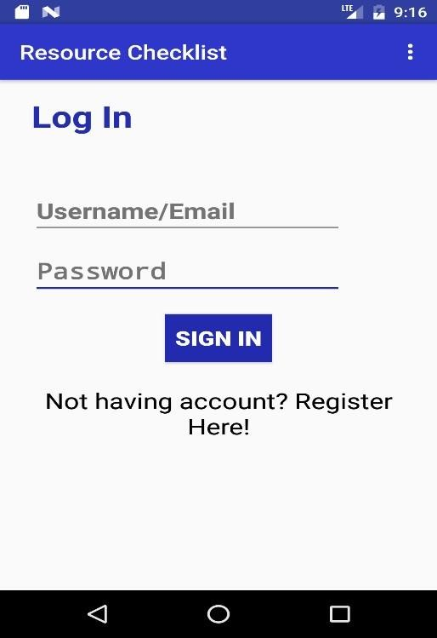

**Invalid credentials:**

**Invalid Credentials:**

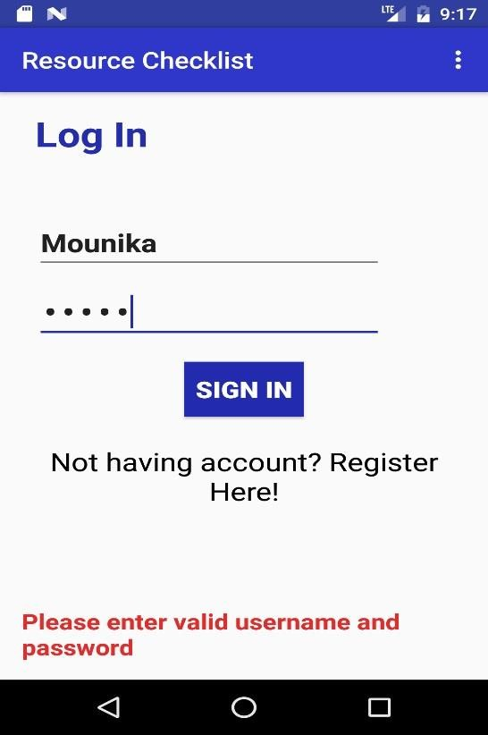

**Registration Page:**

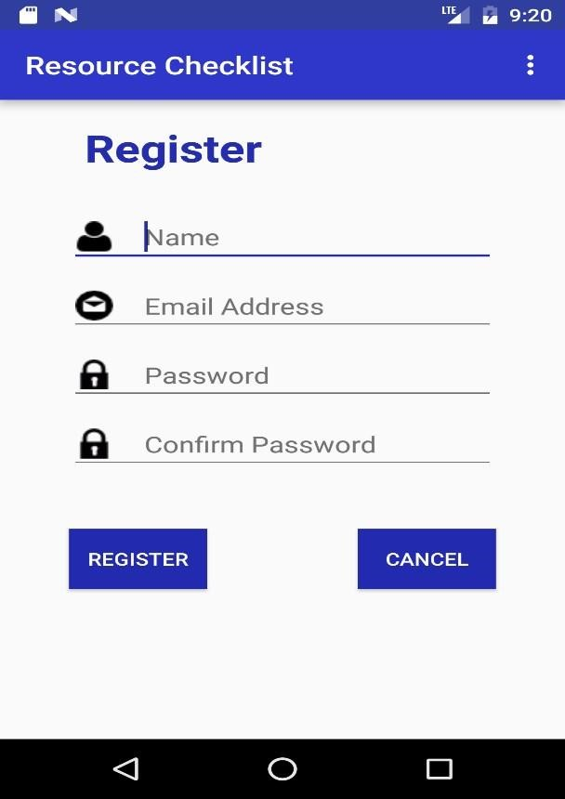

**Invalid email-id:**

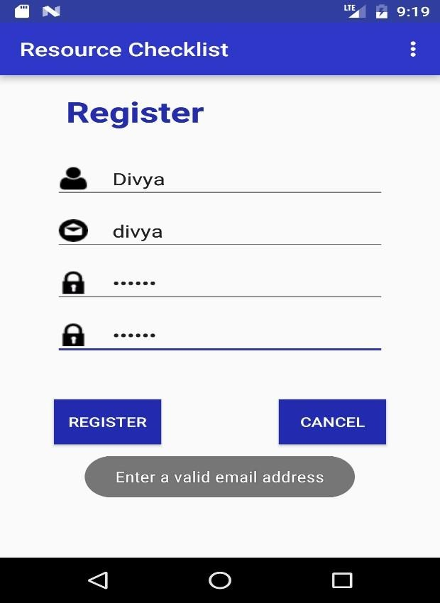

**Password mismatch:**

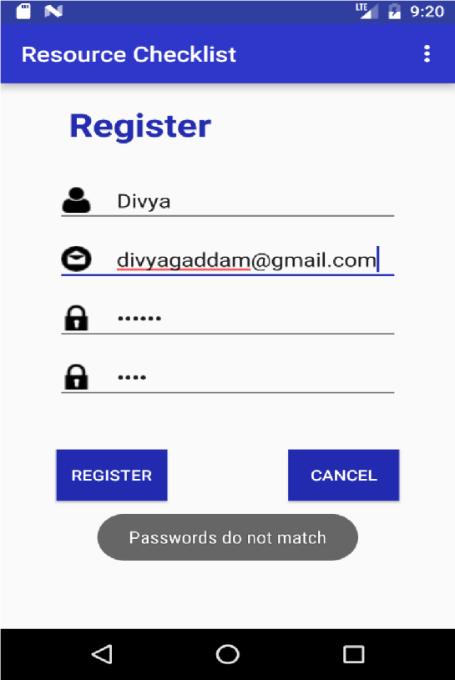

**Invalid password:**

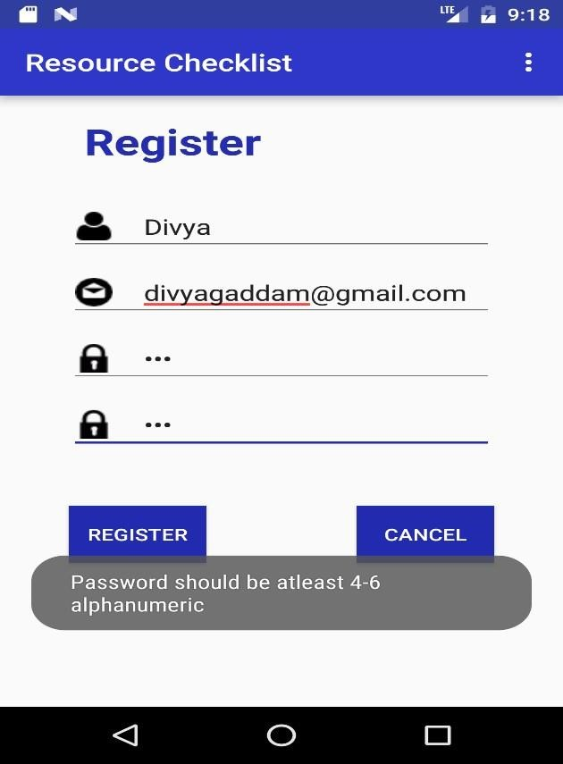

**Home Page:**

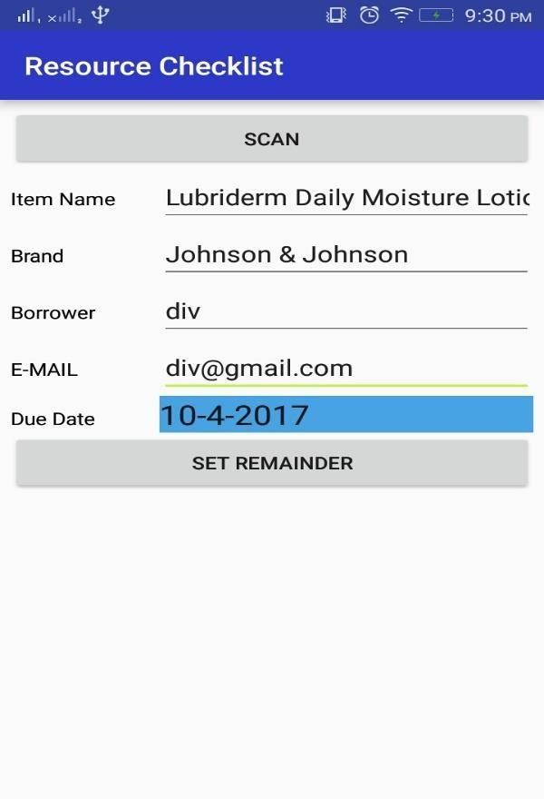

**Scanning Item:**

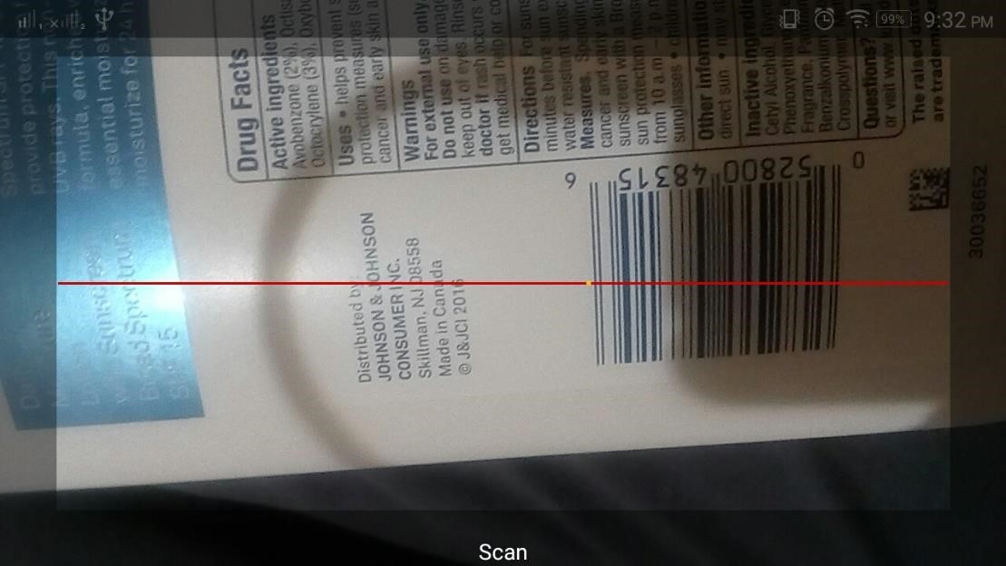

**Calendar option for due date:**

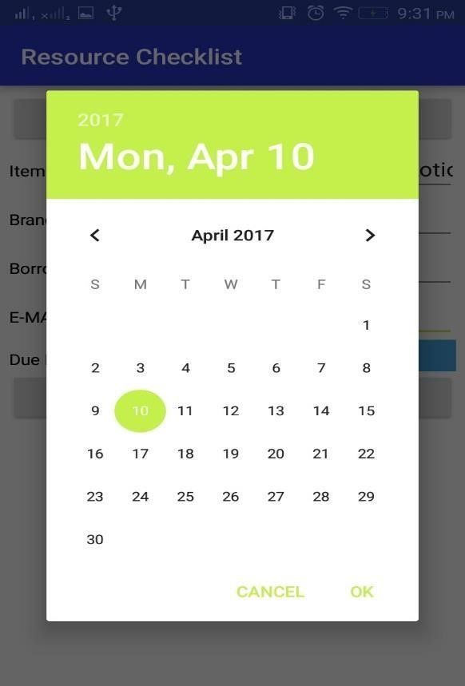

**Price Comparison:**

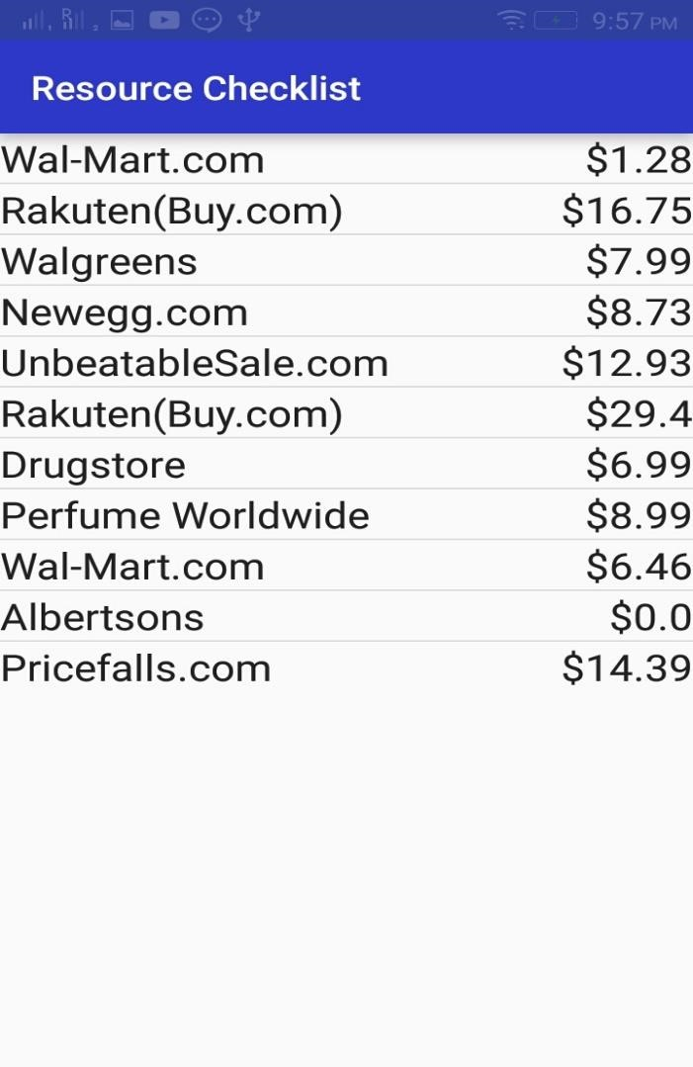

**Redirecting to website:**

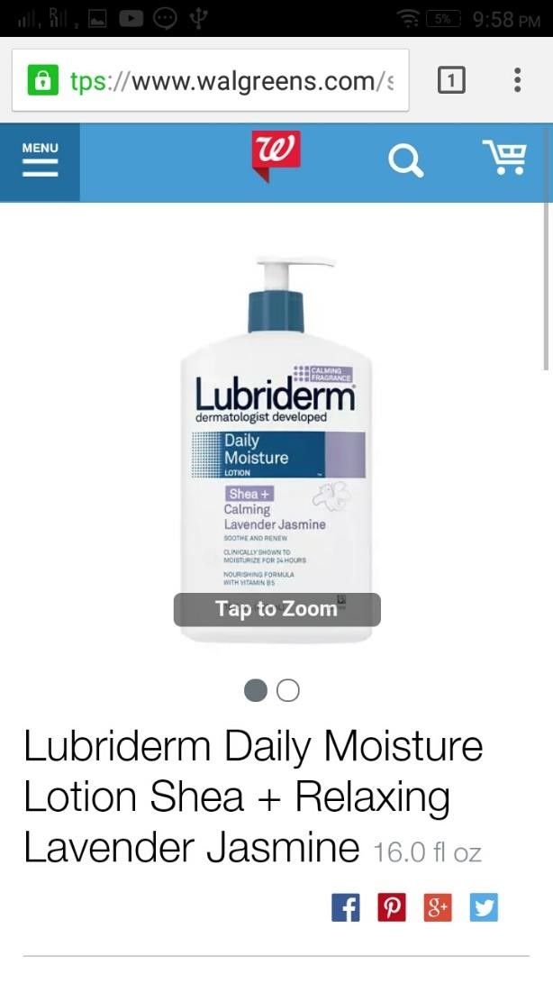

**HISTORY:**

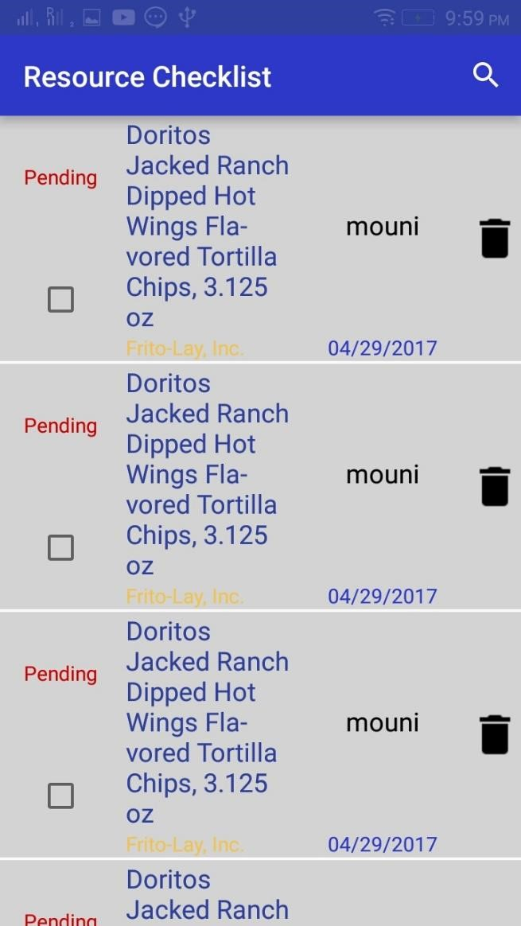

**Select an entry to send reminder:**

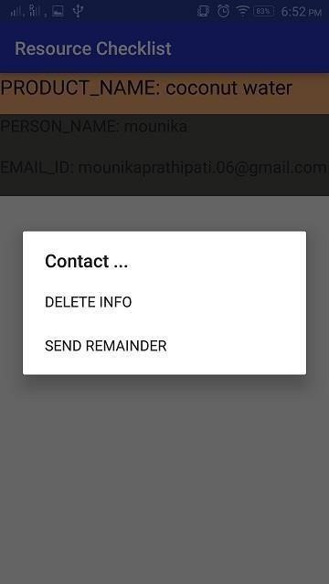

**Sending Reminder:**

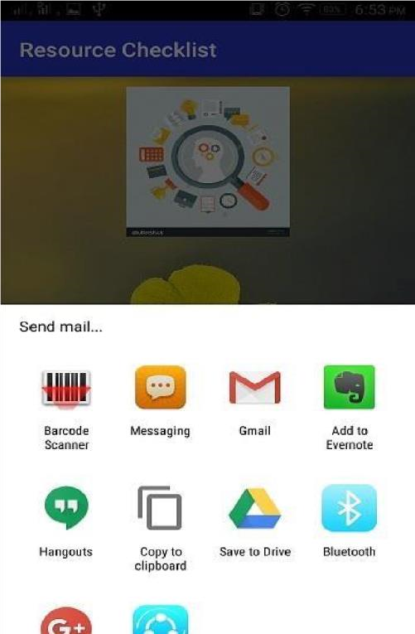

**Sending message:**

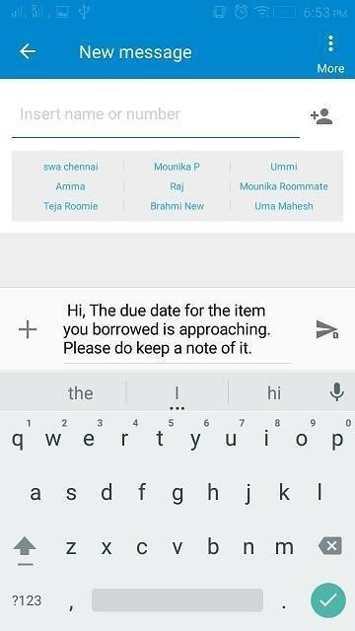

**Sending email:**

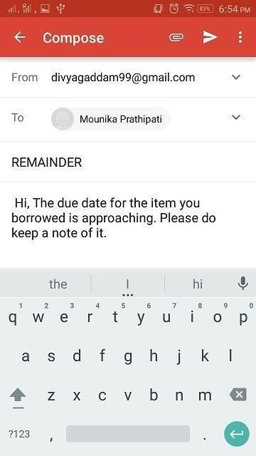

**List of known bugs and deficiencies:**

1. In the Home page, if there is low light while scanning the item, the item barcode may not be scanned properly. In this case, we have to adjust the brightness of light.
2. In any page, if the input format is incorrect, the system may not respond properly. For example, in the text field if you give image as input, the application cannot handle this kind of situations. So, always valid inputs must be given.

**Project management:**



**Resource Checklist**

(Project Proposal and Plan)

**By**

***Team Name – Decoders***

***Team No# 20***

Swathi Jasthi

Divya Gaddam

Mounika Prathipati

Uma Maheswara Reddy Mandapati

**COMP-SCI 5551 Adv Software Engineering**

**University of Missouri Kansas City**

**Spring – 2016**

**Contents**

Project Goal and Objectives 3

Motivation 3

Significance/Uniqueness 3

Obectives 3

System Features 4

Related Work 4

Backup Project 4

Bibliography 5

# 

**Project Goal and Objectives:**

**Motivation:**

In today’s busy life, resource monitoring has become a big issue because of the growing work pressure and social pressure we may forget the things we had lent. I had a real-time experience with this kind of situation. I had lent a book to my friend which I found to be very motivational and interesting but I forgot to take it back. After few months, I thought of reading the book again and searched for it but I cannot find it. I was not able to recollect where I had kept the book or whom I had given to. After two years, when my friend was shifting home, he found the book in their store room and returned it to me asking apologies for the mistake. Most of my friends tell me that they faced a situation like this in their life. So, we thought that there is need to develop a resource management system for people. The application can be used for keeping record of the items being borrowed by individuals. As smart phones are becoming part of our lives, it is the best choice to deploy our resource management system.

**Objective:**

The application mainly aims at keeping track of various items such as books, tablets or any other devices either by a barcode scan or by taking a picture manually even by entering the current location of borrower. The scope of this application is that it can be used by anyone who wants to keep track of their belongings.

**Significance/Uniqueness:**

Although there are other applications which can remind you of the things which you have lent, our application differs from them because of the following features:

* The applications which are present currently can remind you just with the text which you had written for that reminder, but in our application, we had incorporated two new features as the user can associate a picture with it or he can have a bar code scan for the particular item which he is lending. The reminder in our application will show you that information also.
* In our application, a message (either a text message or an email) will be sent to both the lender and the borrower saying that the due date is approaching for the item. This will ensure better security.

**System Features:**

The resource monitoring app can be used to keep track of items.

The system features include:

* Users can scan the item that they are lending, and then enter the details of the person whom they are lending it to.
* They can also store the information of the items that do not have a barcode, this can be done by taking the picture of the item manually and storing the details of the borrower.
* Send Email or text message to the borrower as a reminder
* Uses SQLite database for the implementation of storing the details
* All the details are stored in a List View format and can be viewed from history
* Delete the details when we get back the item.

**Related Work:**

We are taking the below project as a reference

<https://github.com/graceeunbekim/listme>

<https://github.com/NativeScript/sample-Groceries>

<https://github.com/altron42/tripLOG-test>

**Backup Project:**

**Health care manager –**There are two tasks this will do. They are the emergency alarm and healthcare management system. Initially the person i.e. patient should register for the first time by providing his/her user-id, password, name and mobile number. After signup, user must provide details of friends and family members/Doctor such as their name and mobile number to whom the emergency alert must be sent during an emergency. Then the user can enter name of the problem he/she has, to suggest prescription. For example, if the user is suffering from fever then user may enter symptom as fever and must provide description for that like headache, nausea and so on. Based on the symptom details, user would get prescription from the doctor. User can also go through the tips that are provided by the doctor and under emergency like hazards the user can send alert to his friends.

**Bibliography:**

<https://developers.google.com/maps/documentation/javascript/get-api-key>

<https://www.youtube.com/playlist?list=PL6gx4Cwl9DGBsvRxJJOzG4r4k_zLKrnxl>

<https://developer.android.com/training/basics/firstapp/creating-project.html>

<https://www.udacity.com/course/android-development-for-beginners--ud837>



**Resource Checklist**

(Increment - 1)

**By**

***Team Name – Decoders***

***Team No# 20***

Swathi Jasthi

Divya Gaddam

Mounika Prathipati

Uma Maheswara Reddy Mandapati

**COMP-SCI 5551 Adv Software Engineering**

**University of Missouri Kansas City**

**Spring – 2016**

**Contents**

**Project Goal and Objectives ........................................................................................ 2**

**Motivation .............................................................................................................. 3**

**Significance/Uniqueness ......................................................................................... 3**

**Obectives ................................................................................................................ 3**

**System Features ..................................................................................................... 4**

**First Increment Report……………………………………………………………………………………………….4**

**Existing Services/Rest API……………………………………………………………………………………...4**

**Detail Design Features…………………………………………………………………………………………...4 Testing……………………………………………………………………….…………………………………….……...10**

**Implementation……………………………………………………………………………………………..….….…10 Deployment……………………………………………………………………………………………………….…….15**

**Project Management………………………………………………………………………………………….…….15**

**Bibliography………………………………………………………………………………………………………….....16**

# Project Goal and Objectives:

### Motivation:

In today’s busy life, resource monitoring has become a big issue because of the growing work pressure and social pressure we may forget the things we had lent. I had a real-time experience with this kind of situation. I had lent a book to my friend which I found to be very motivational and interesting but I forgot to take it back. After few months, I thought of reading the book again and searched for it but I cannot find it. I was not able to recollect where I had kept the book or whom I had given to. After two years, when my friend was shifting home, he found the book in their store room and returned it to me asking apologies for the mistake. Most of my friends tell me that they faced a situation like this in their life. So, we thought that there is need to develop a resource management system for people. The application can be used for keeping record of the items being borrowed by individuals. As smart phones are becoming part of our lives, it is the best choice to deploy our resource management system.

**Objective:**

The application mainly aims at keeping track of various items such as books, tablets or any other devices either by a barcode scan or by taking a picture manually even by entering the current location of borrower. The scope of this application is that it can be used by anyone who wants to keep track of their belongings.

### Significance/Uniqueness:

Although there are other applications which can remind you of the things which you have lent, our application differs from them because of the following features:

* The applications which are present currently can remind you just with the text which you had written for that reminder, but in our application, we had incorporated two new features as the user can associate a picture with it or he can have a bar code scan for the item which he is lending. The reminder in our application will show you that information also.
* In our application, a message (either a text message or an email) will be sent to both the lender and the borrower saying that the due date is approaching for the item. This will ensure better security.

### System Features:

The resource monitoring app can be used to keep track of items.

The system features include:

* Users can scan the item that they are lending, and then enter the details of the person whom they are lending it to.
* They can also store the information of the items that do not have a barcode, this can be done by taking the picture of the item manually and storing the details of the borrower.
* Send Email or text message to the borrower as a reminder
* Uses SQLite database for the implementation of storing the details
* All the details are stored in a List View format and can be viewed from history• Delete the details when we get back the item.

## First Increment Report:

### Existing Services/REST API:

**API’s Used:** Facebook Login API and Google API.

### Detail Design of Features:

**Wireframes:**

**Login Page:**

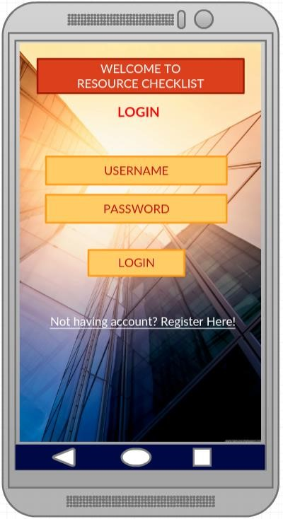

**Register Page:**

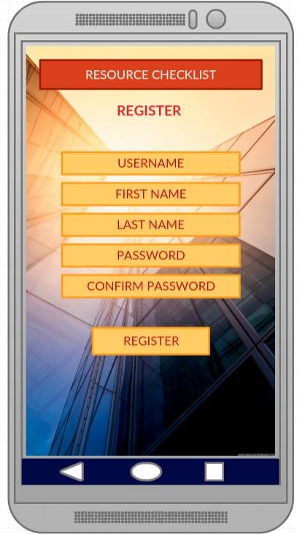

**Home Page:**

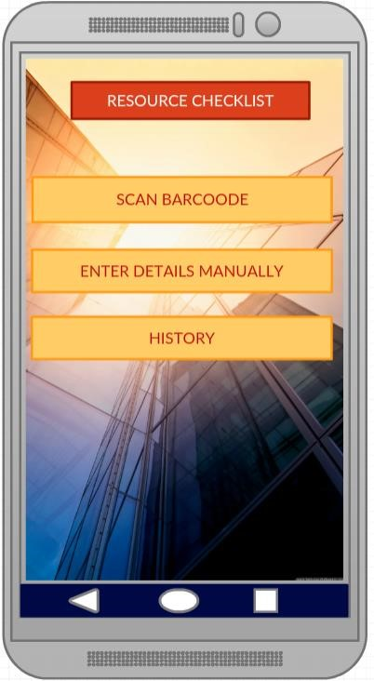

**Manual Entry:**

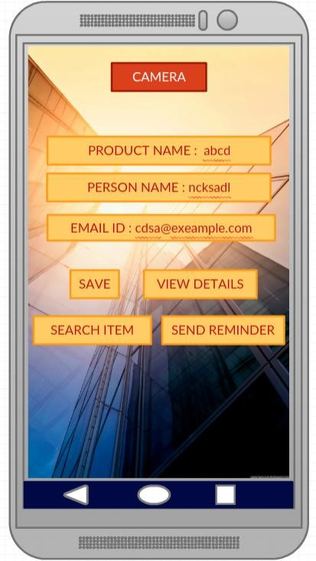

**Product Search:**

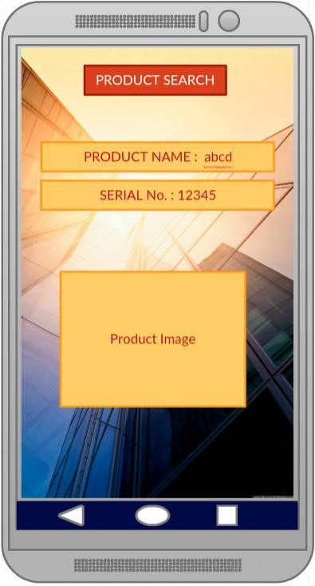

**Scan Item:**

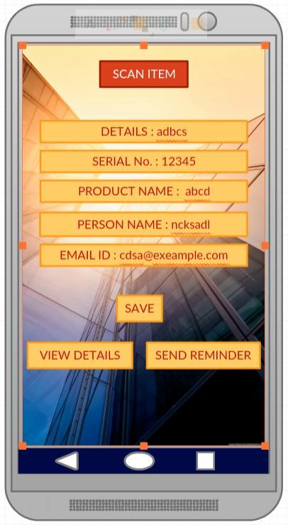

**Architecture Diagram:**

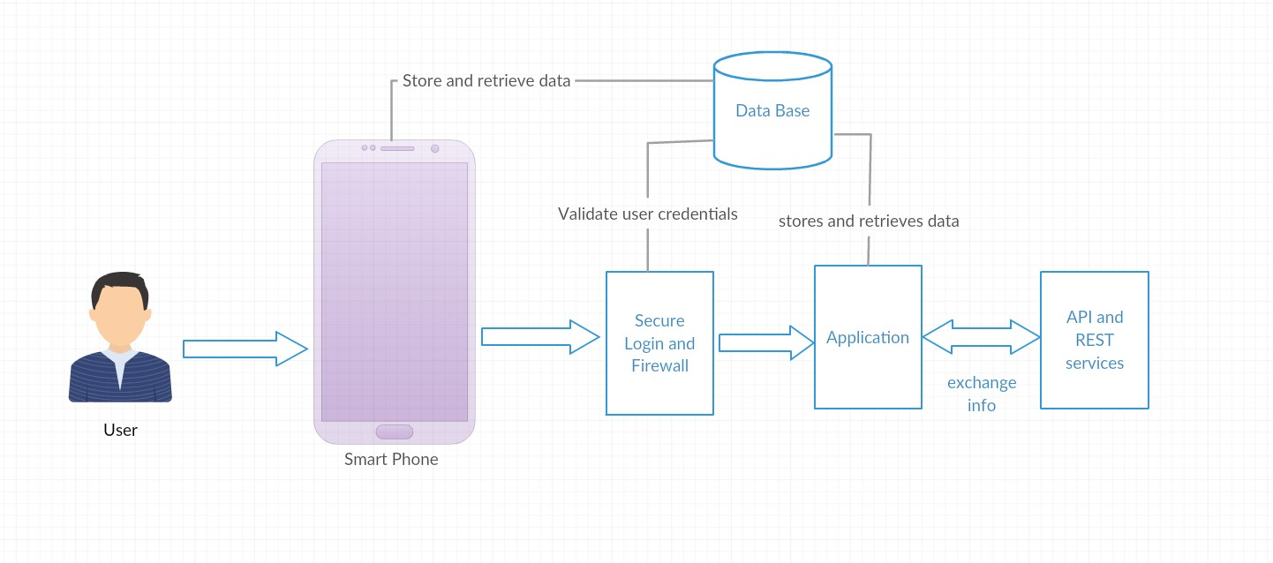

**Sequence Diagram:**

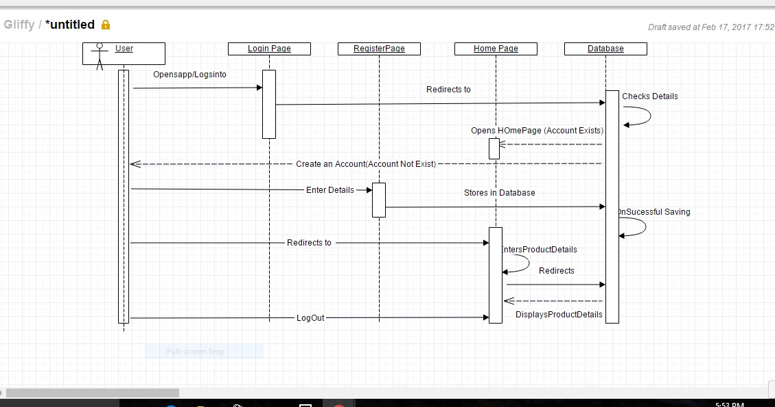

**Class Diagram:**

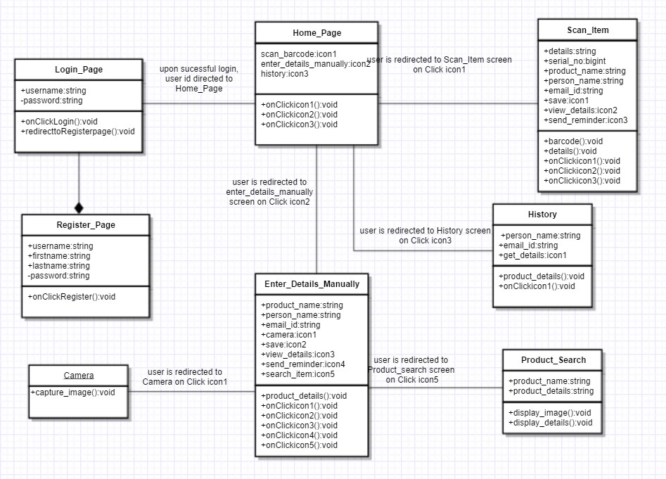

**Use Case:**

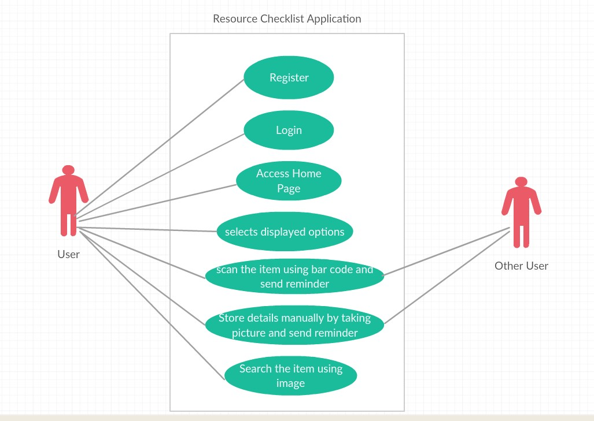

**User Stories:**

1. Plan the increments to create resource management application.
2. Finalize the project plan and document the revised project plan.
3. As a user, I should be able to login into the resource checklist application.
4. As a user, I should to have options to register to the application to use it.
5. The user should be redirected to the Home Page after a successful login.
6. The user should have two options to enter a product details. One is through Barcode scanning and the other is to enter the details manually.

# Testing:

**Unit Testing:**

|  |  |  |  |
| --- | --- | --- | --- |
| **User**  **Story**  **Number** | **Test Case Description** | **Expected Result** | **Test Result** |
| **3** | **Enter invalid mail ID and valid password** | **Error message should come as “invalid credentials”** | **PASS** |
| **3** | **Enter valid mail ID and invalid password** | **Error message should be displayed as “invalid credentials”** | **PASS** |
| **3** | **Enter invalid mail ID and invalid password** | **Error message should come as “invalid credentials”** | **PASS** |
| **5** | **Enter valid mail ID and valid password** | **User is redirected to Homepage successfully** | **PASS** |
| **4** | **Enter a word without @gmail.com at the end of the string in email ID field** | **Error message should be displayed as “enter valid mail ID”** | **PASS** |
| **4** | **Enter a password with length less than 4 characters** | **Gives error message “password should have minimum of 5 characters”** | **PASS** |
| **4** | **Enter two different passwords in password field and confirm password field.** | **Gives error message “passwords do not match”** | **PASS** |
| **4** | **Enter all the fields in register page correctly** | **User is redirected to home page successfully** | **PASS** |

# Implementation:

The “Resource Checklist” application has implemented in Android Studio onto an emulator. Below screenshots describes the flow  **Login Page:**

.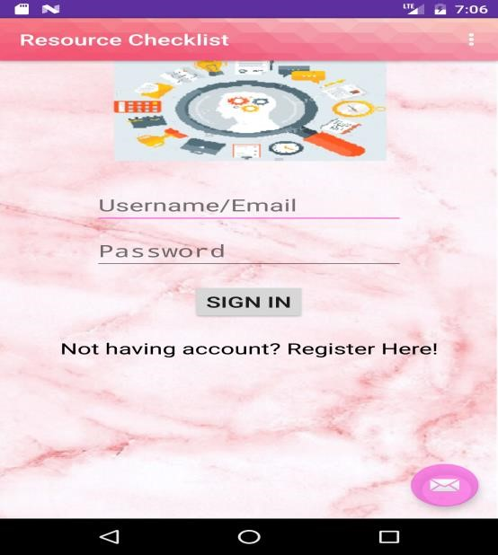

**Invalid Credentials:**

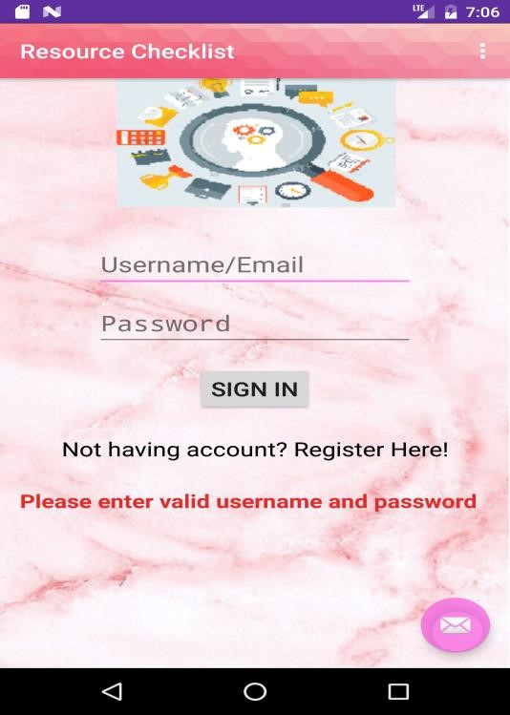

**Successful Login:**

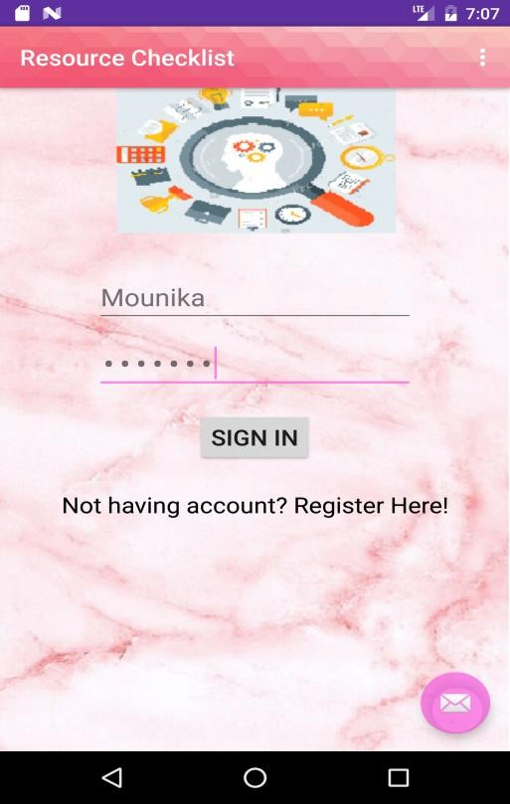

**Registration Page:**

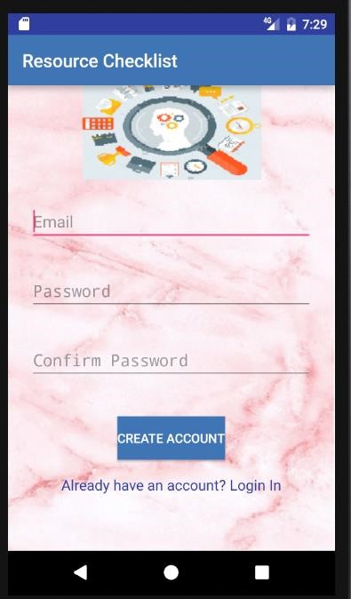

**Invalid Credentials:**

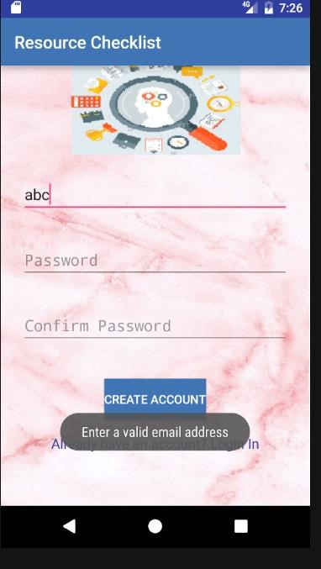

**Password Verification:**

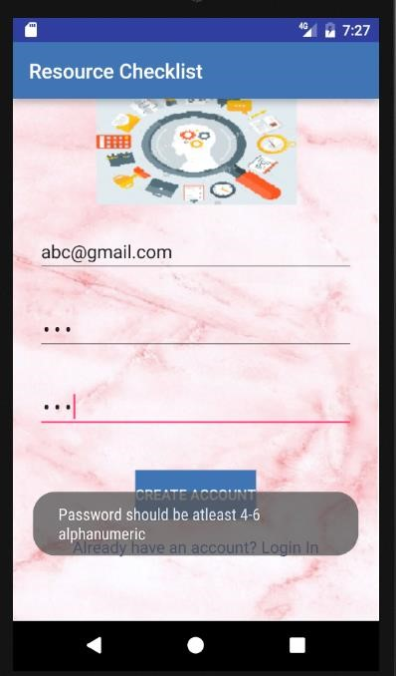

**Home Page:**

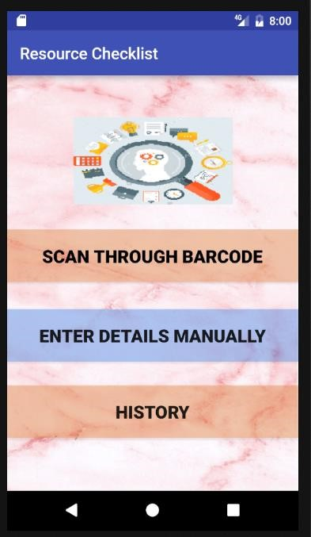

# Deployment:

The “Resource Checklist” application has implemented in Android Studio onto an emulator of which screenshots are provided above.

# Project Management:

**Implementation status Report:**

**Work Completed:**

* Wire Frames and Mockups

Contributor – Uma Maheshwara Reddy Mandapati

Time taken – 5 hours

Contributions – 25%

* Architecture diagram, Class diagram
* Use Case diagram, Sequence diagram Contributor – Mounika Prathipati

Time taken – 20 hours

Contributions – 25%

* Set up required tools such as android studio, zenhub and github, visio
* Finalizing the required API useful for the application.

Contributor – Swathi Jasthi

Time taken – 20 hours

Contributions – 25%

* Login, Registration and Home page

Contributor – Divya Gaddam, Uma maheshwara Reddy

Time taken – 20 hours

Contributions – 25%

**Work to be completed:**

* Design the barcode scanning page

Responsibility – Swathi Jasthi

Estimated hours – 80 hours

* Enter the details manually page

Responsibility – Mounika Prathipati

Estimated hours – 80 hours

* Implement the object detection feature

Responsibility – Divya Gaddam

Estimated hours – 80 hours

* Improve the user interface of the application

Responsibility – Uma Maheshwara Reddy Mandapati

Estimated hours – 80 hours

# Bibliography:

<https://developers.google.com/maps/documentation/javascript/get-api-key><https://www.youtube.com/playlist?list=PL6gx4Cwl9DGBsvRxJJOzG4r4k_zLKrnxl><https://developer.android.com/training/basics/firstapp/creating-project.html>[https://www.udacity.com/course/android](https://www.udacity.com/course/android-development-for-beginners--ud837)-development-for-beginners--ud837



**Resource Checklist**

(Increment -2)

**By**

***Team Name – Decoders***

***Team No# 20***

Swathi Jasthi

Divya Gaddam

Mounika Prathipati

Uma Maheswara Reddy Mandapati

**COMP-SCI 5551 Adv Software Engineering**

**University of Missouri Kansas City**

**Spring – 2016**

**Contents**

**Project Goal and Objectives ........................................................................................ 2**

**Motivation .............................................................................................................. 3**

**Significance/Uniqueness ......................................................................................... 3**

**Objectives ............................................................................................................... 3**

**System Features ..................................................................................................... 4**

**Second Increment Report………………………………………………………………………………………….4**

**Existing Services/Rest API……………………………………………………………………………………...4**

**Detail Design Features…………………………………………………………………………………………...4**

**User stories……………………………………………………………………………………………………………….11**

**Testing……………………………………………………………………….…………………………………….……...14**

**Implementation……………………………………………………………………………………………..….….…15**

**Deployment……………………………………………………………………………………………………….…….24**

**Project Management………………………………………………………………………………………….…….24**

**Bibliography………………………………………………………………………………………………………….....25**

**Project Goal and Objectives:**

**Motivation:**

In today’s busy life, resource monitoring has become a big issue because of the growing work pressure and social pressure we may forget the things we had lent. I had a real-time experience with this kind of situation. I had lent a book to my friend which I found to be very motivational and interesting but I forgot to take it back. After few months, I thought of reading the book again and searched for it but I cannot find it. I was not able to recollect where I had kept the book or whom I had given to. After two years, when my friend was shifting home, he found the book in their store room and returned it to me asking apologies for the mistake. Most of my friends tell me that they faced a situation like this in their life. So, we thought that there is need to develop a resource management system for people. The application can be used for keeping record of the items being borrowed by individuals. As smart phones are becoming part of our lives, it is the best choice to deploy our resource management system.

**Objective:**

The application mainly aims at keeping track of various items such as books, tablets or any other devices either by a barcode scan or by taking a picture manually even by entering the current location of borrower. The scope of this application is that it can be used by anyone who wants to keep track of their belongings.

**Significance/Uniqueness:**

Although there are other applications which can remind you of the things which you have lent, our application differs from them because of the following features:

* The applications which are present currently can remind you just with the text which you had written for that reminder, but in our application, we had incorporated two new features as the user can associate a picture with it or he can have a bar code scan for the item which he is lending. The reminder in our application will show you that information also.
* In our application, a message (either a text message or an email) will be sent to both the lender and the borrower saying that the due date is approaching for the item. This will ensure better security.

**System Features:**

The resource monitoring app can be used to keep track of items. The system features include:

* Users can scan the item that they are lending, and then enter the details of the person whom they are lending it to.
* They can also store the information of the items that do not have a barcode, this can be done by taking the picture of the item manually and storing the details of the borrower.
* Send Email or text message to the borrower as a reminder
* Uses SQLite database for the implementation of storing the details
* All the details are stored in a List View format and can be viewed from history Delete the details when we get back the item.

**Second Increment Report:**

**Existing Services/REST API:**

**API’s Used:** Facebook Login API and Google API.

**Detail Design of Features:**

**Wireframes:**

**Login Page:**

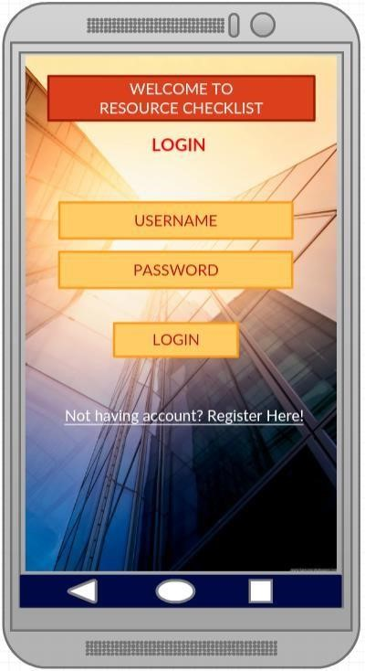

**Register Page:**

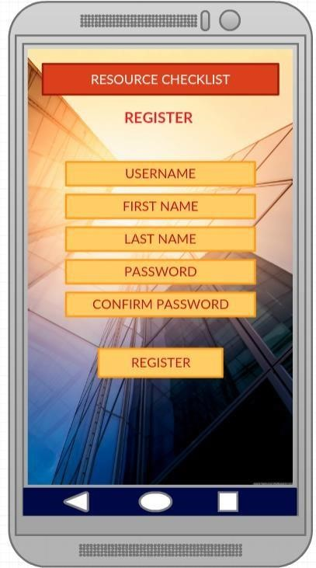

**Home Page:**

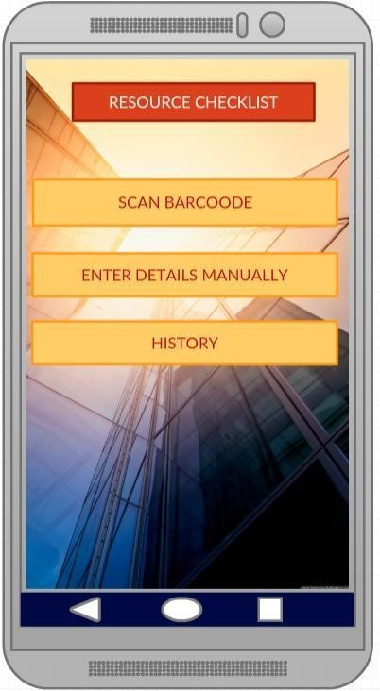

**Manual Entry:**

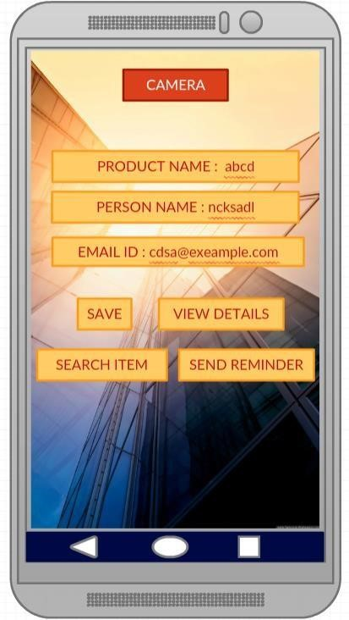

**Product Search:**

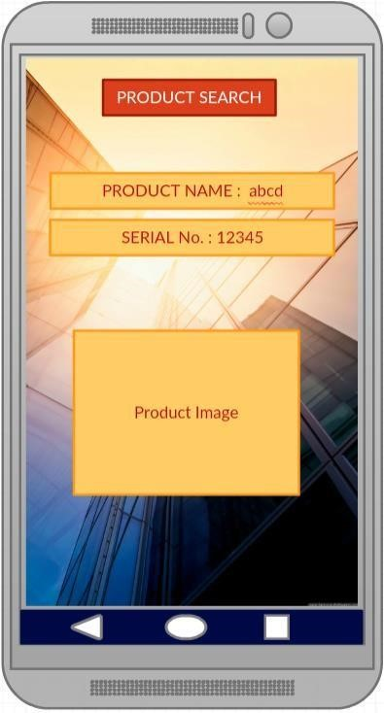

**Scan Item:**

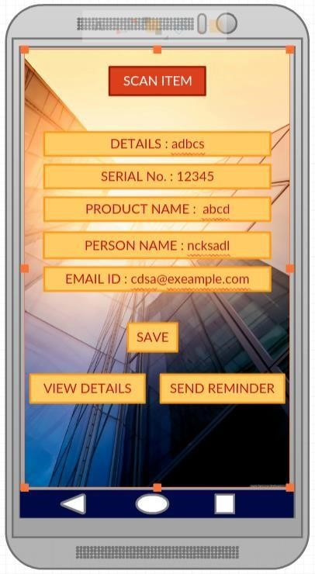

**History:**

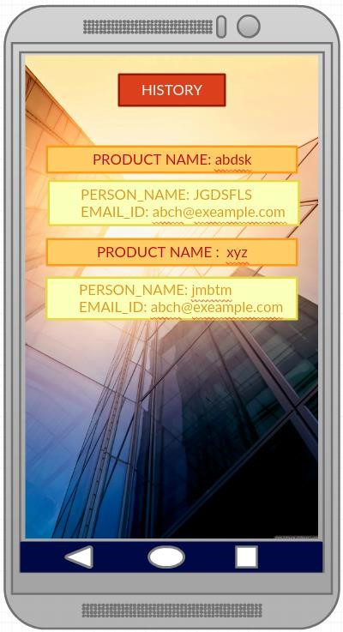

**Selecting an item from history:**

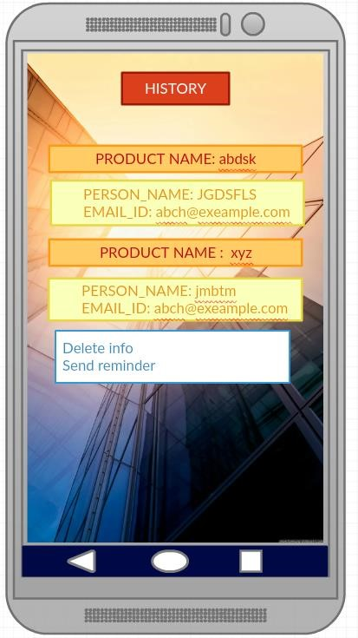

**Architecture Diagram:**

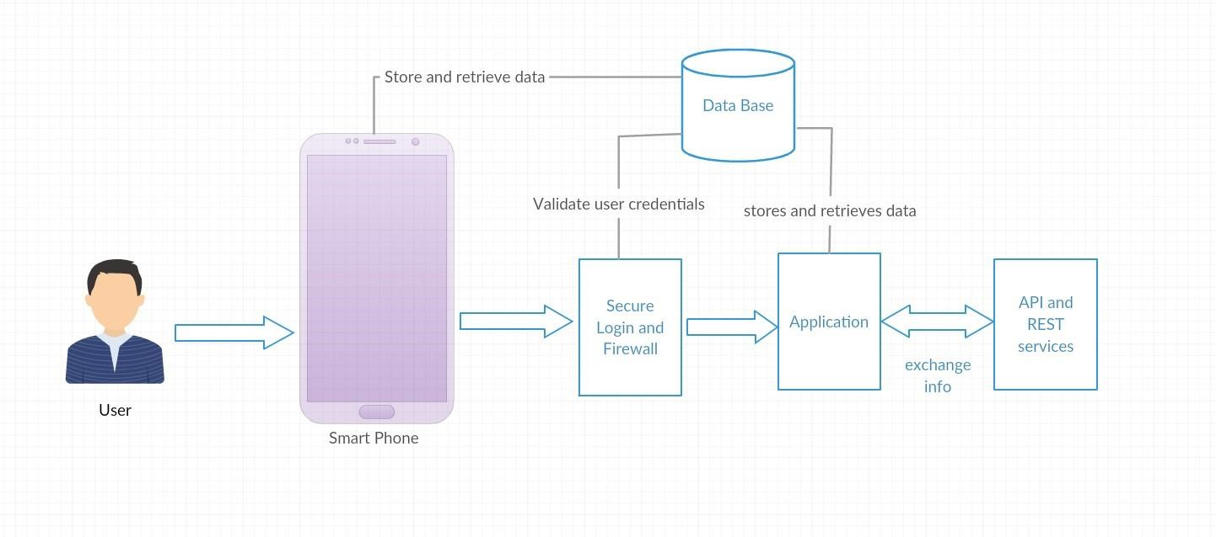

**Sequence Diagram:**

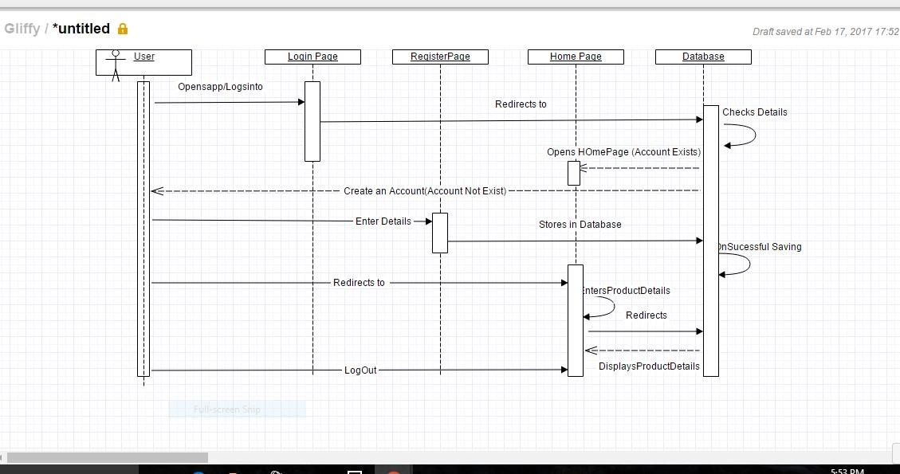

**Class Diagram:**

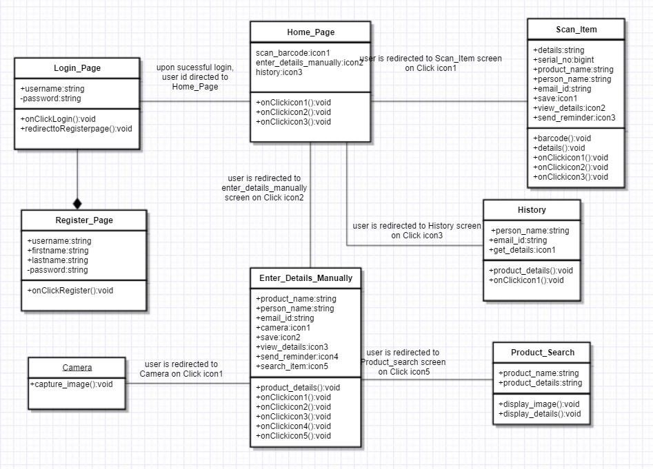

Page

**Use Case:**

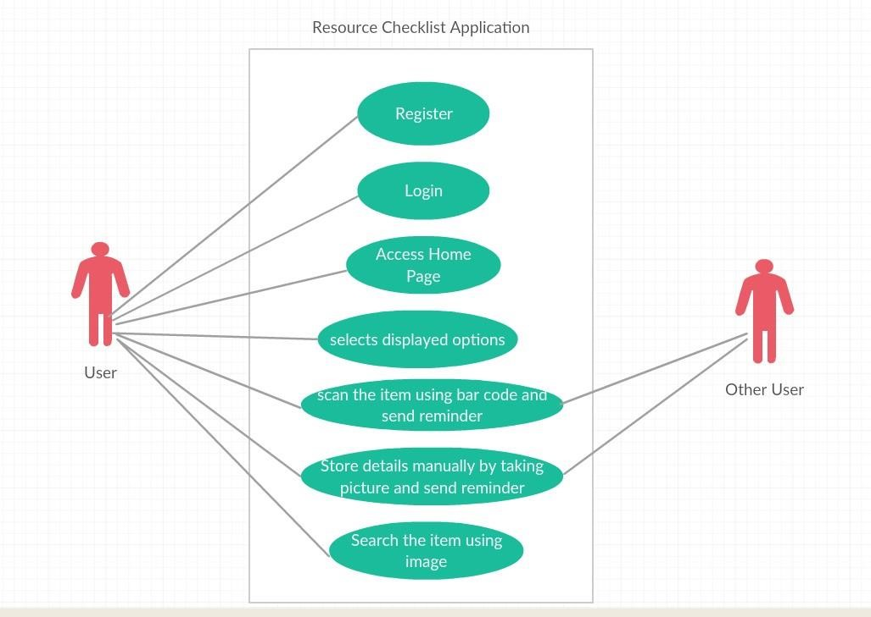

**User Stories:**

1. Plan the increments to create resource management application.
2. Finalize the project plan and document the revised project plan.
3. As a user, I should be able to login into the resource checklist application.
4. As a user, I should to have options to register to the application to use it.
5. The user should be redirected to the Home Page after a successful login.
6. The user should have two options to enter a product details. One is through Barcode scanning and the other is to enter the details manually.
7. Being a user I can scan the item through Barcode Scanner and able to add it to my database using SQLite to history.
8. Sending text message or Email to the corresponding borrower to remind him saying his due date is approaching.
9. Sending remainder to the person repeatedly from history by selecting the corresponding item.
10. I could be flexible in erasing item details from history if I do not want anymore.

**ISSUES:**

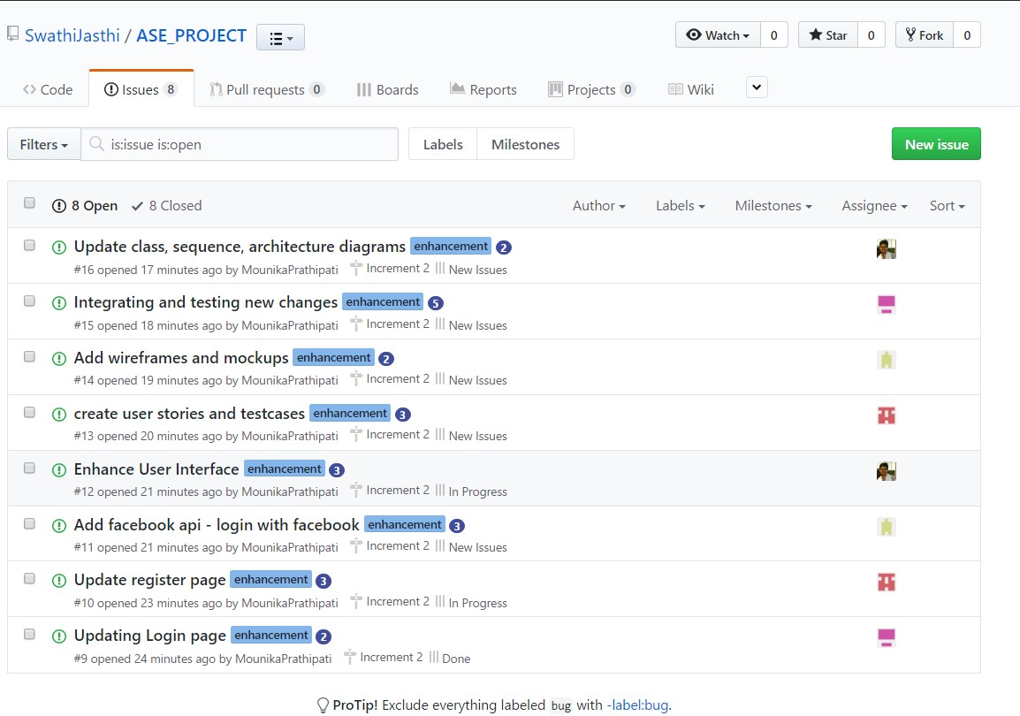

**BOARD:**

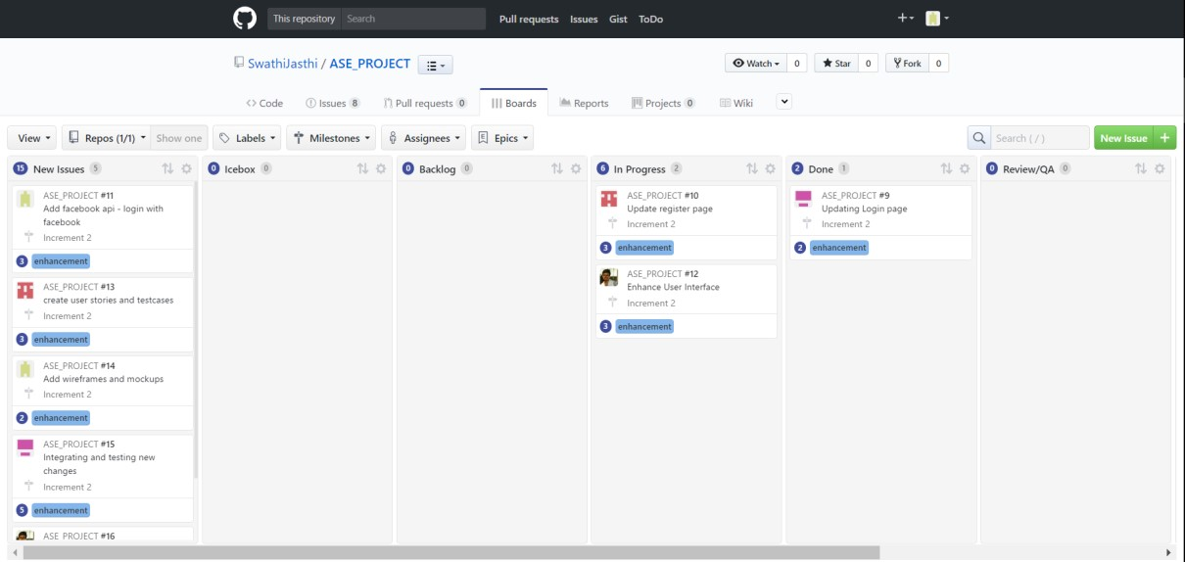

**BURNDOWN CHART:**

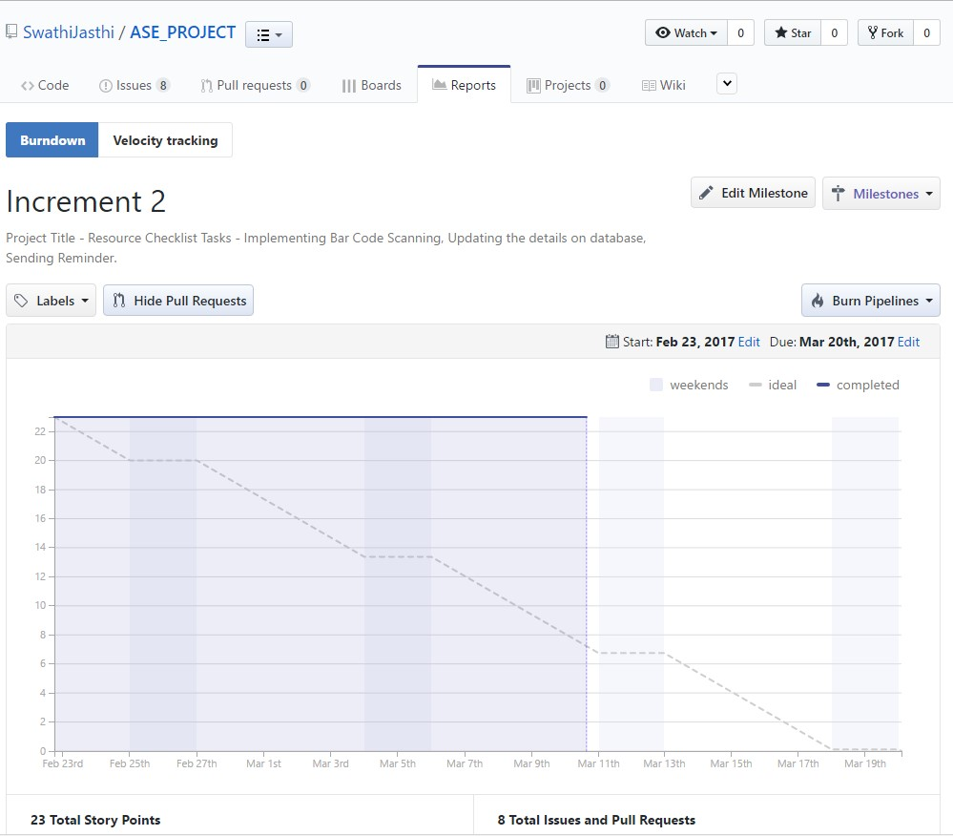

**Testing:**

**Unit Testing:**

|  |  |  |  |
| --- | --- | --- | --- |
| **User**  **Story**  **Number** | **Test Case Description** | **Expected Result** | **Test**  **Result** |
| **3** | **Enter invalid mail ID and valid password** | **Error message should come as “invalid credentials”** | **PASS** |
| **3** | **Enter valid mail ID and invalid password** | **Error message should be displayed as “invalid credentials”** | **PASS** |
| **3** | **Enter invalid mail ID and invalid password** | **Error message should come as “invalid credentials”** | **PASS** |
| **5** | **Enter valid mail ID and valid password** | **User is redirected to Homepage successfully** | **PASS** |
| **4** | **Enter a word without @gmail.com at the end of the string in email ID field** | **Error message should be displayed as “enter valid mail ID”** | **PASS** |
| **4** | **Enter a password with length less than 4 characters** | **Gives error message “password should have minimum of 5 characters”** | **PASS** |
| **4** | **Enter two different passwords in password field and confirm password field.** | **Gives error message “passwords do not match”** | **PASS** |
| **4** | **Enter all the fields in register page correctly** | **User is redirected to home page successfully** | **PASS** |
| **7** | **Scanning the item through Barcode**  **Scanner** | **Scanning the Barcode** | **PASS** |
| **7** | **Details are to be saved** | **Displaying the saved results** | **PASS** |
| **8** | **Sending the reminder to the corresponding person** | **Reminder sent** | **PASS** |
| **9** | **After Sending the reminder the details are to be saved** | **Details are saved and can view in history** | **PASS** |
| **10** | **Flexibility in clearing the unwanted data** | **Cleared the data** | **PASS** |

**Implementation:**

The “Resource Checklist” application has implemented in Android Studio onto an

Android mobile. Below screenshots describes the flow  **Login Page:**

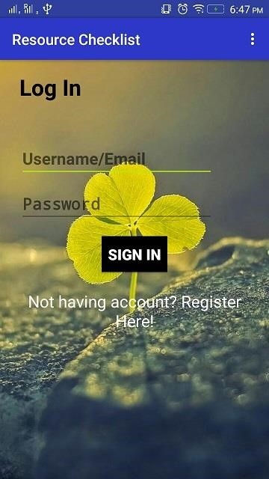

**Invalid Credentials:**

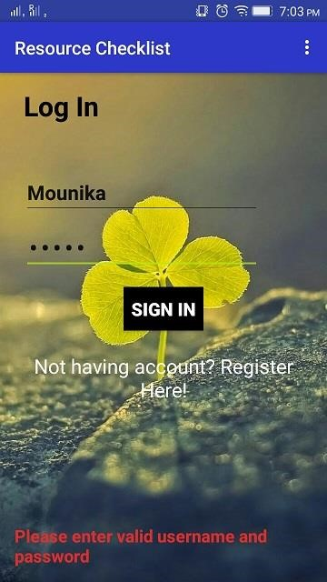

**Registration Page:**

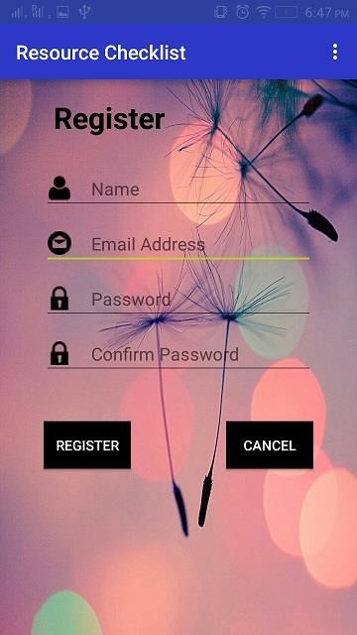

**Invalid email-id:**

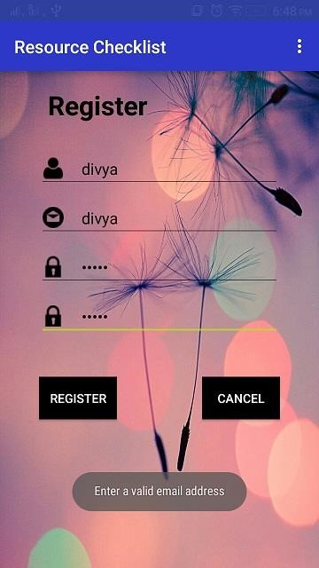

**Invalid Password:**

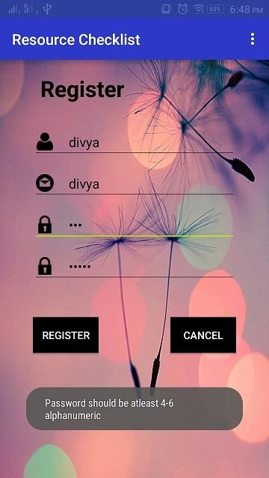

**Password mismatch:**

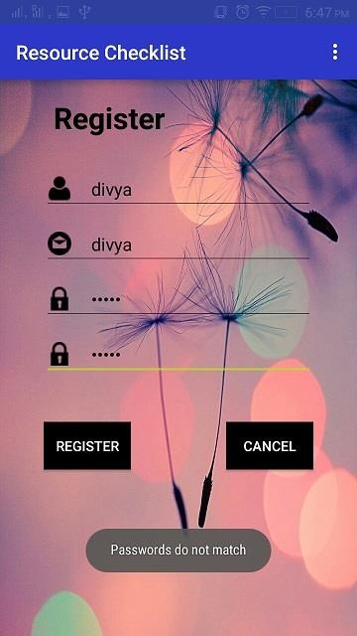

**Home Page:**

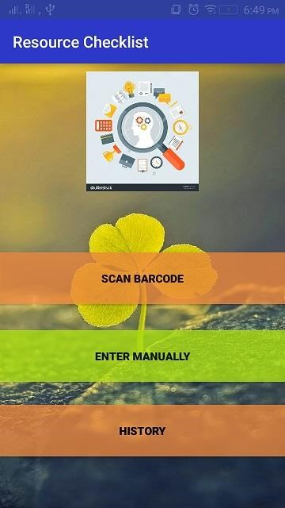

**SCAN ITEM:**

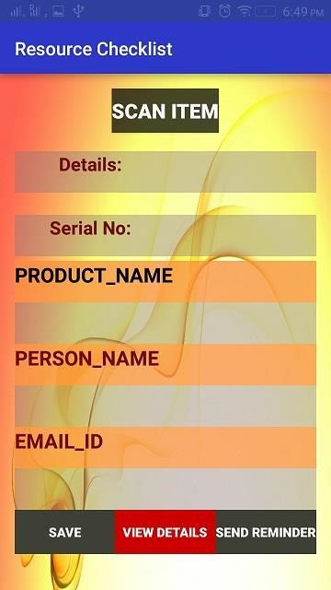

**Scanning Item:**

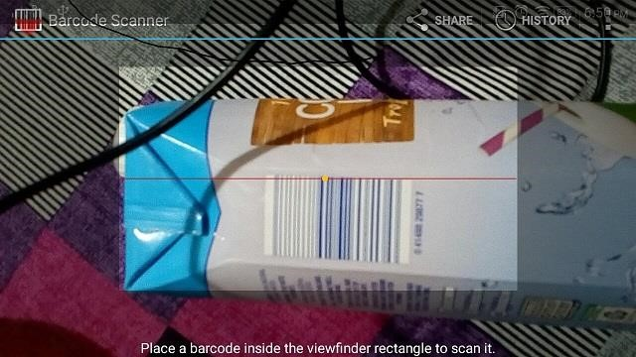

**Details are populated after scan:**

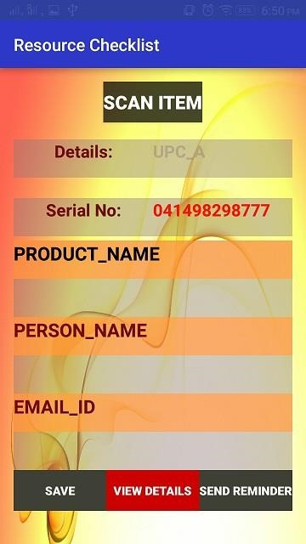

**Adding Borrower Details:**

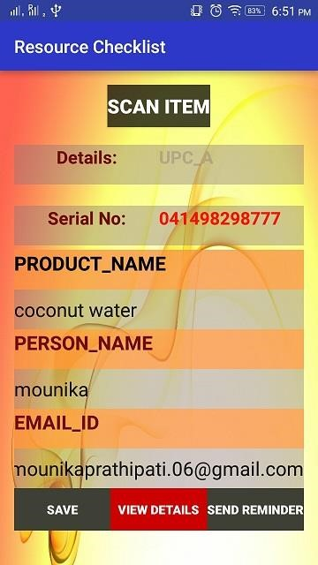

**Details are saved successfully:**

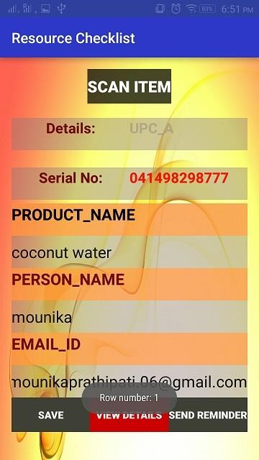

**HISTORY:**

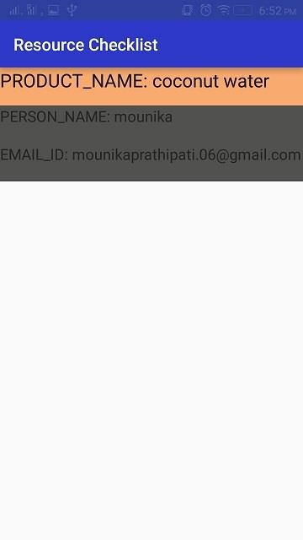

**Select an entry to send reminder:**

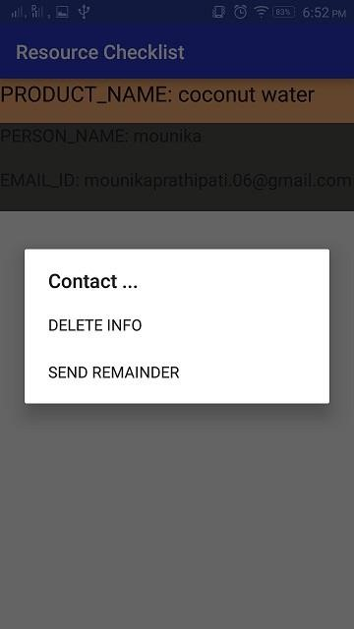

**Sending Reminder:**

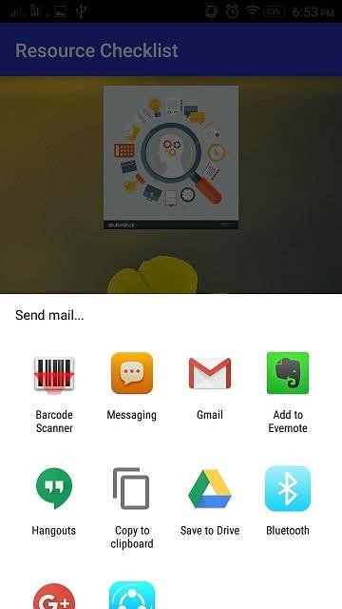

**Sending message:**

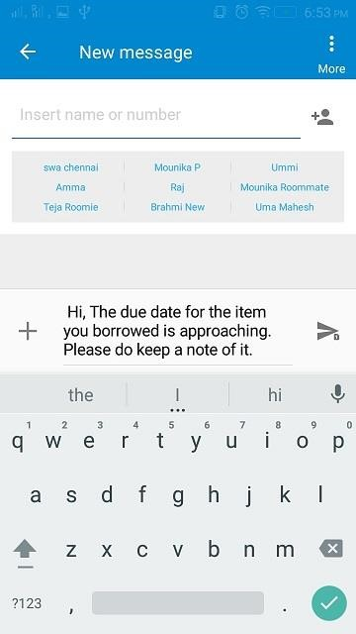

**Sending email:**

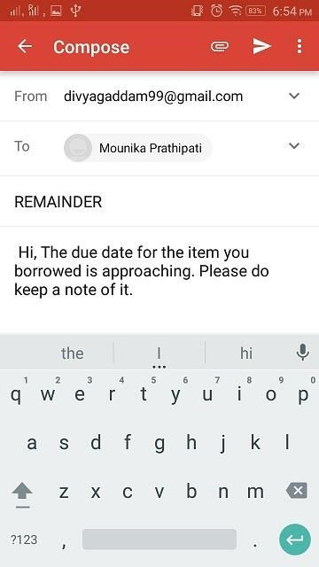

**Deployment:**

The “Resource Checklist” application has implemented in Android Studio onto an emulator of which screenshots are provided above.

**Project Management:**

**Implementation status Report:**

**Work Completed:**

* Barcode implementation

Contributor – Uma Maheshwara Reddy Mandapati

Time taken – 20 hours

Contributions – 25%

* Database implementation

Contributor – Mounika Prathipati

Time taken – 20 hours

Contributions – 25%

* History page implementation

Contributor – Swathi Jasthi

Time taken – 20 hours

Contributions – 25%

* UI modification, Layouts, mockups

Contributor – Divya Gaddam

Time taken – 20 hours

Contributions – 25%

**Work to be completed:**

* Enter details manually

Responsibility – Swathi Jasthi

Estimated hours – 80 hours

* UI modification, adding Facebook login

Responsibility – Mounika Prathipati

Estimated hours – 80 hours

* Object detection

Responsibility – Divya Gaddam

Estimated hours – 80 hours

* Linking to database using SQLite

Responsibility – Uma Maheshwara Reddy Mandapati Estimated hours – 80 hours

**Bibliography:**

<https://developers.google.com/maps/documentation/javascript/get-api-key><https://www.youtube.com/playlist?list=PL6gx4Cwl9DGBsvRxJJOzG4r4k_zLKrnxl><https://developer.android.com/training/basics/firstapp/creating-project.html><https://www.udacity.com/course/android-development-for-beginners--ud837>

<https://www.gliffy.com/><https://creately.com/>

<https://github.com/KeepSafe/android-resource-remover>



**Resource Checklist**

(Increment -3)

**By**

***Team Name – Decoders***

***Team No# 20***

Swathi Jasthi

Divya Gaddam

Mounika Prathipati

Uma Maheswara Reddy Mandapati

**COMP-SCI 5551 Adv Software Engineering**

**University of Missouri Kansas City**

**Spring – 2016**

**Contents**

**Project Goal and Objectives ........................................................................................ 2**

**Motivation .............................................................................................................. 3**

**Significance/Uniqueness ......................................................................................... 3**

**Objectives ............................................................................................................... 3**

**System Features ..................................................................................................... 4**

**Second Increment Report………………………………………………………………………………………….4**

**Existing Services/Rest API……………………………………………………………………………………...4**

**Detail Design Features…………………………………………………………………………………………...4**

**User stories……………………………………………………………………………………………………………….11**

**Testing……………………………………………………………………….…………………………………….……...14**

**Implementation……………………………………………………………………………………………..….….…15**

**Deployment……………………………………………………………………………………………………….…….24**

**Project Management………………………………………………………………………………………….…….24**

**Bibliography………………………………………………………………………………………………………….....25**

**Project Goal and Objectives:**

**Motivation:**

In today’s busy life, resource monitoring has become a big issue because of the growing work pressure and social pressure we may forget the things we had lent. I had a real-time experience with this kind of situation. I had lent a book to my friend which I found to be very motivational and interesting but I forgot to take it back. After few months, I thought of reading the book again and searched for it but I cannot find it. I was not able to recollect where I had kept the book or whom I had given to. After two years, when my friend was shifting home, he found the book in their store room and returned it to me asking apologies for the mistake. Most of my friends tell me that they faced a situation like this in their life. So, we thought that there is need to develop a resource management system for people. The application can be used for keeping record of the items being borrowed by individuals. As smart phones are becoming part of our lives, it is the best choice to deploy our resource management system.

**Objective:**

The application mainly aims at keeping track of various items such as books, tablets or any other devices either by a barcode scan or by taking a picture manually even by entering the current location of borrower. The scope of this application is that it can be used by anyone who wants to keep track of their belongings.

**Significance/Uniqueness:**

Although there are other applications which can remind you of the things which you have lent, our application differs from them because of the following features:

* The applications which are present currently can remind you just with the text which you had written for that reminder, but in our application, we had incorporated two new features as the user can associate a picture with it or he can have a bar code scan for the item which he is lending. The reminder in our application will show you that information also.
* In our application, a message (either a text message or an email) will be sent to both the lender and the borrower saying that the due date is approaching for the item. This will ensure better security.

**System Features:**

The resource monitoring app can be used to keep track of items. The system features include:

* Users can scan the item that they are lending, and then enter the details of the person whom they are lending it to.
* They can also store the information of the items that do not have a barcode, this can be done by taking the picture of the item manually and storing the details of the borrower.
* Send Email or text message to the borrower as a reminder
* Uses SQLite database for the implementation of storing the details
* All the details are stored in a List View format and can be viewed from history Delete the details when we get back the item.

**Second Increment Report:**

**Existing Services/REST API:**

**API’s Used:** Facebook Login API and Google API.

**Detail Design of Features:**

**Wireframes:**

**Login Page:**

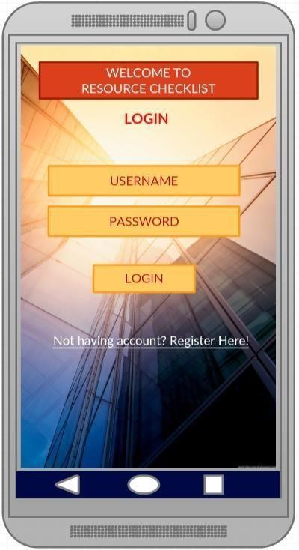

**Register Page:**

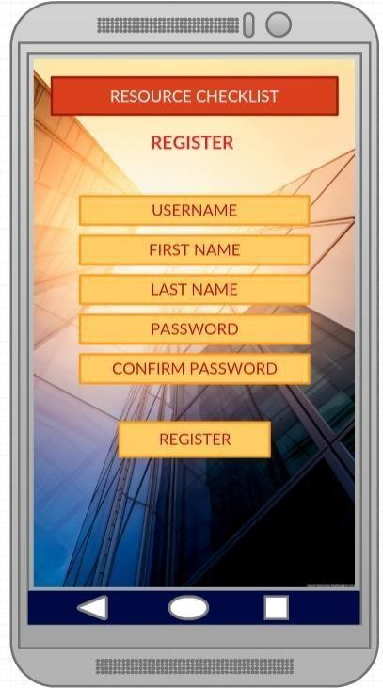

**Home Page:**

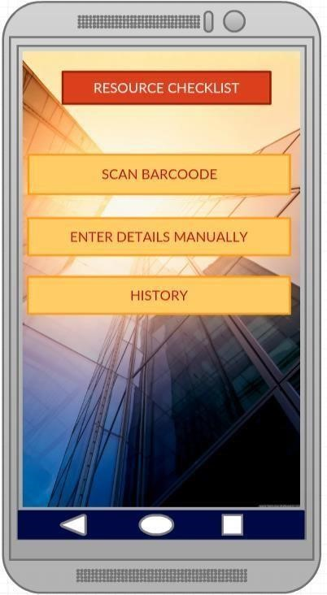

**Manual Entry:**

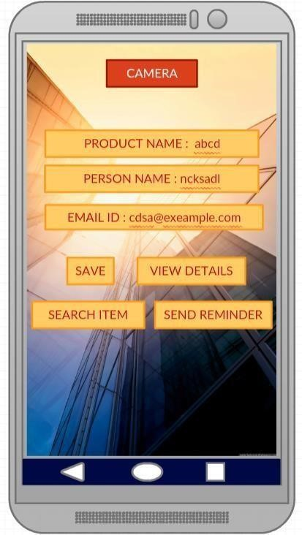

**Product Search:**

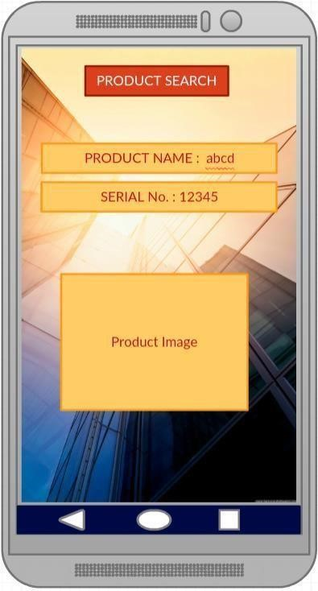

**Scan Item:**

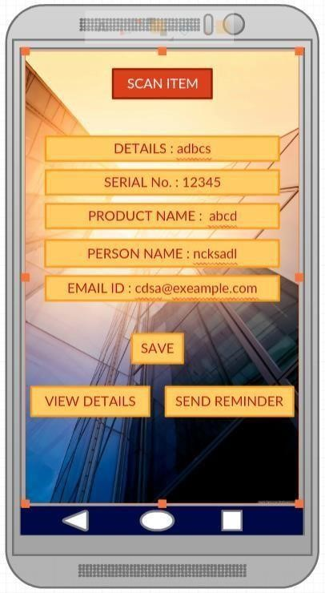

**History:**

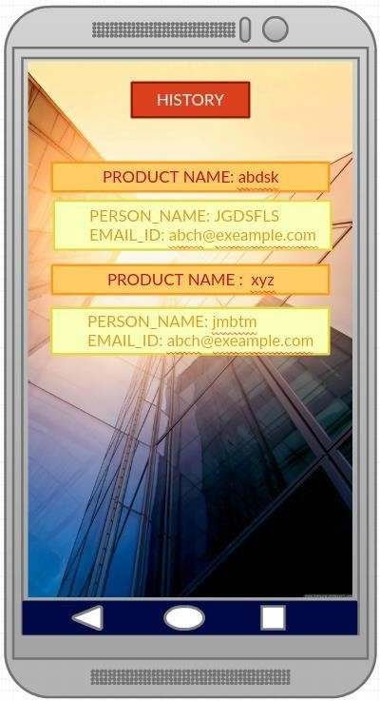

**Selecting an item from history:**

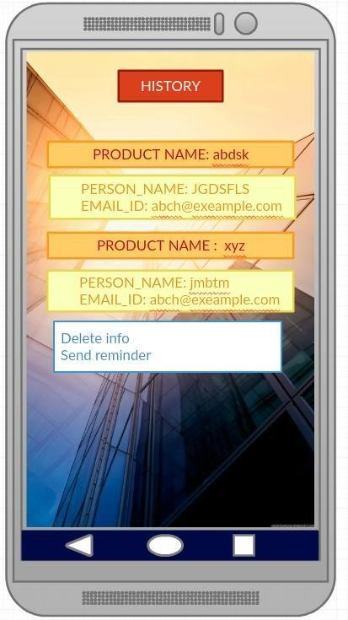

**Architecture Diagram:**

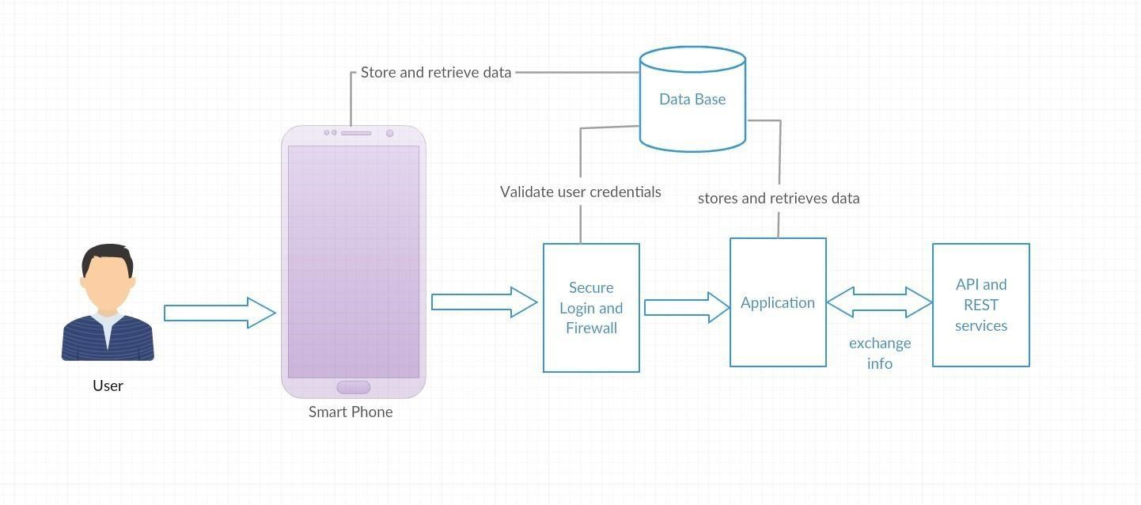

**Sequence Diagram:**

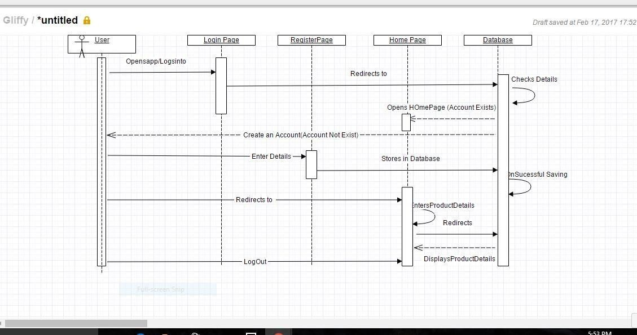

**Class Diagram:**

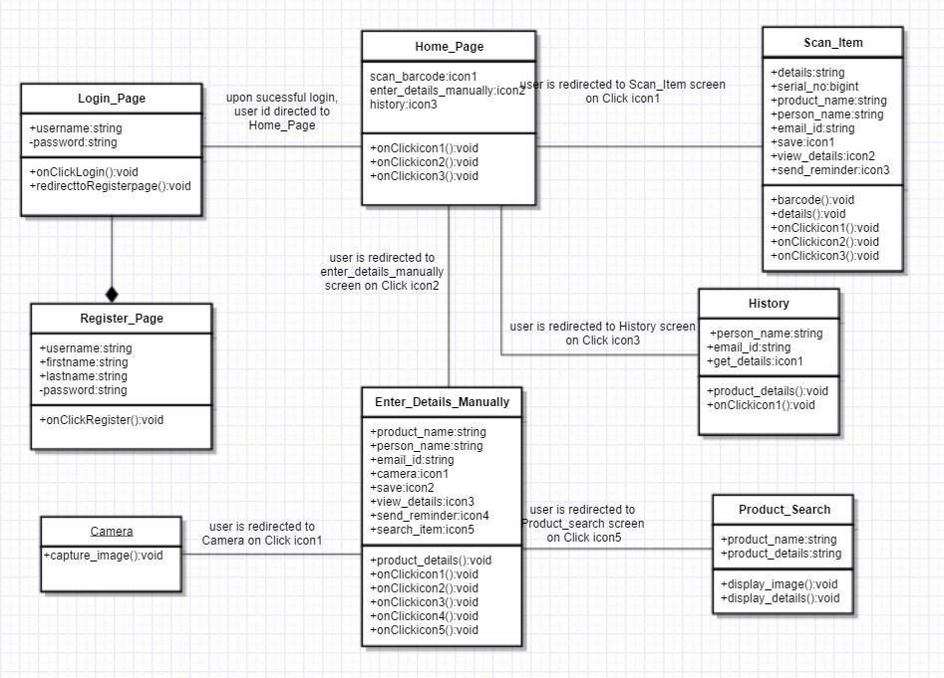

Page

**Use Case:**

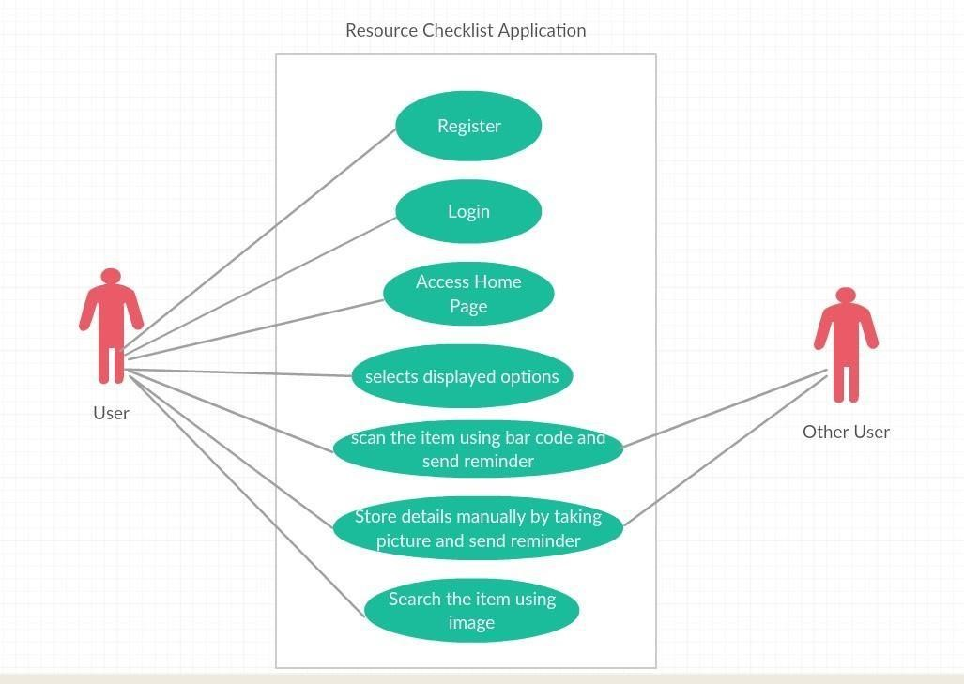

**User Stories:**

1. Plan the increments to create resource management application.
2. Finalize the project plan and document the revised project plan.
3. As a user, I should be able to login into the resource checklist application.
4. As a user, I should to have options to register to the application to use it.
5. The user should be redirected to the Home Page after a successful login.
6. The user should have two options to enter a product details. One is through Barcode scanning and the other is to enter the details manually.
7. Being a user I can scan the item through Barcode Scanner and able to add it to my database using SQLite to history.
8. Sending text message or Email to the corresponding borrower to remind him saying his due date is approaching.
9. Sending remainder to the person repeatedly from history by selecting the corresponding item.
10. I could be flexible in erasing item details from history if I do not want anymore.

**ISSUES:**

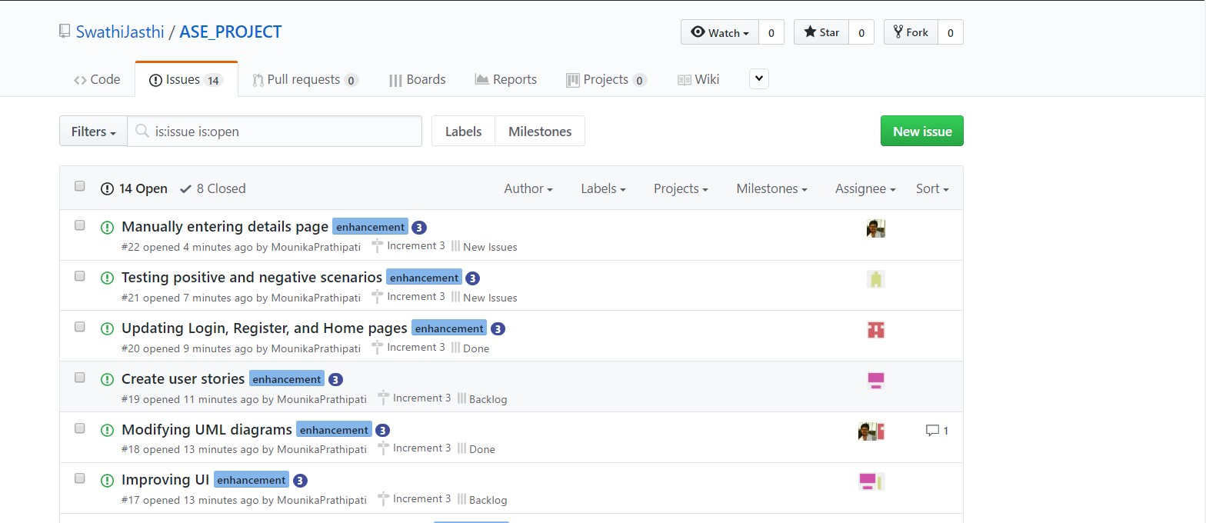

**BOARD:**

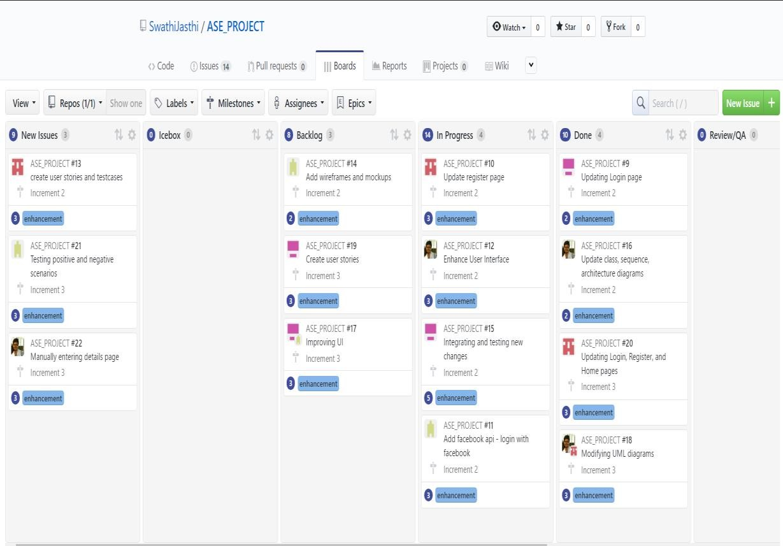

**BURNDOWN CHART:**

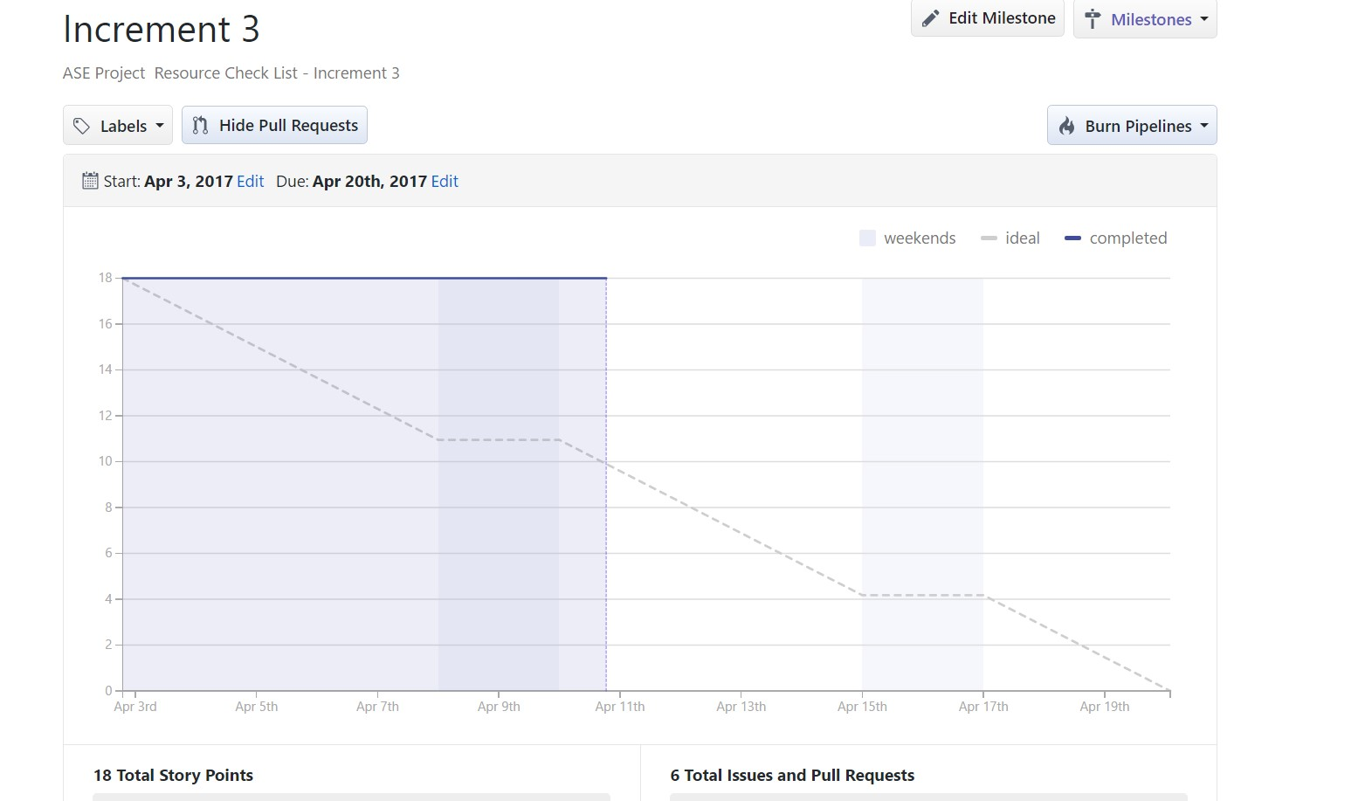

**Testing:**

**Unit Testing:**

|  |  |  |  |
| --- | --- | --- | --- |
| **User**  **Story**  **Number** | **Test Case Description** | **Expected Result** | **Test**  **Result** |
| **3** | **Enter invalid mail ID and valid password** | **Error message should come as “invalid credentials”** | **PASS** |
| **3** | **Enter valid mail ID and invalid password** | **Error message should be displayed as “invalid credentials”** | **PASS** |
| **3** | **Enter invalid mail ID and invalid password** | **Error message should come as “invalid credentials”** | **PASS** |
| **5** | **Enter valid mail ID and valid password** | **User is redirected to Homepage successfully** | **PASS** |
| **4** | **Enter a word without @gmail.com at the end of the string in email ID field** | **Error message should be displayed as “enter valid mail ID”** | **PASS** |
| **4** | **Enter a password with length less than 4 characters** | **Gives error message “password should have minimum of 5 characters”** | **PASS** |
| **4** | **Enter two different passwords in password field and confirm password field.** | **Gives error message “passwords do not match”** | **PASS** |
| **4** | **Enter all the fields in register page correctly** | **User is redirected to home page successfully** | **PASS** |
| **7** | **Scanning the item through Barcode**  **Scanner** | **Scanning the Barcode** | **PASS** |
| **7** | **Details are to be saved** | **Displaying the saved results** | **PASS** |
| **8** | **Sending the reminder to the corresponding person** | **Reminder sent** | **PASS** |
| **9** | **After Sending the reminder the details are to be saved** | **Details are saved and can view in history** | **PASS** |
| **10** | **Flexibility in clearing the unwanted data** | **Cleared the data** | **PASS** |

**Implementation:**

The “Resource Checklist” application has implemented in Android Studio onto an Android mobile. Below screenshots describes the flow  **Login Page:**

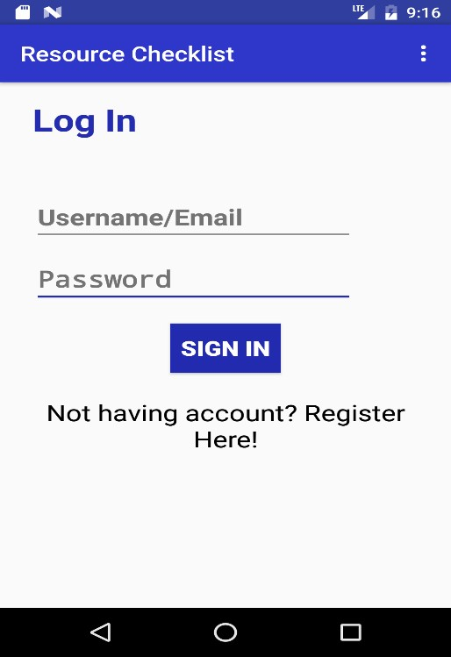

**Invalid Credentials:**

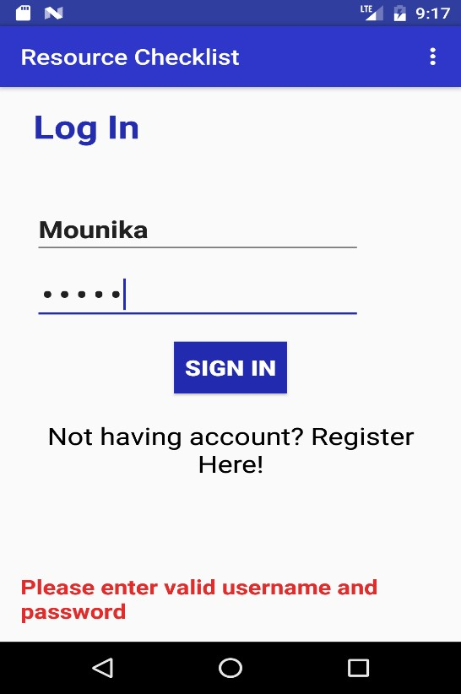

**Registration Page:**

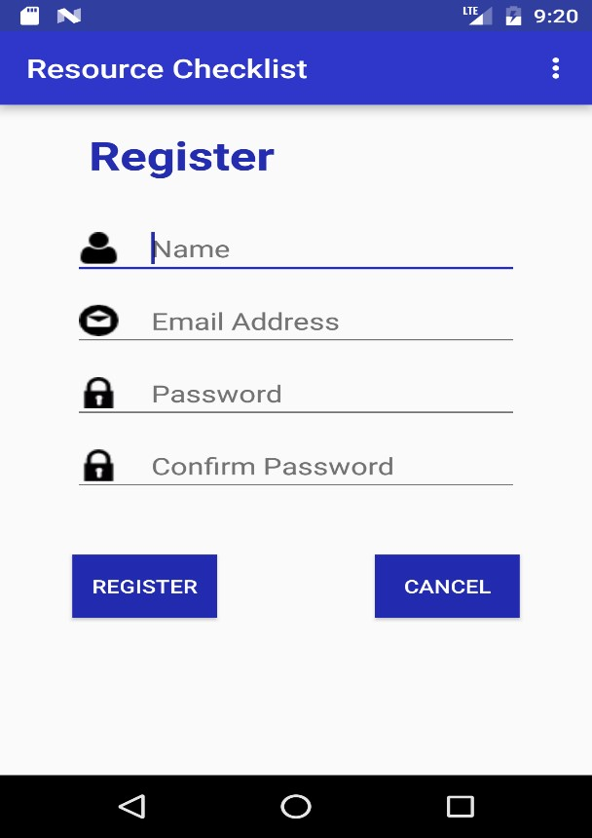

**Invalid email-id:**

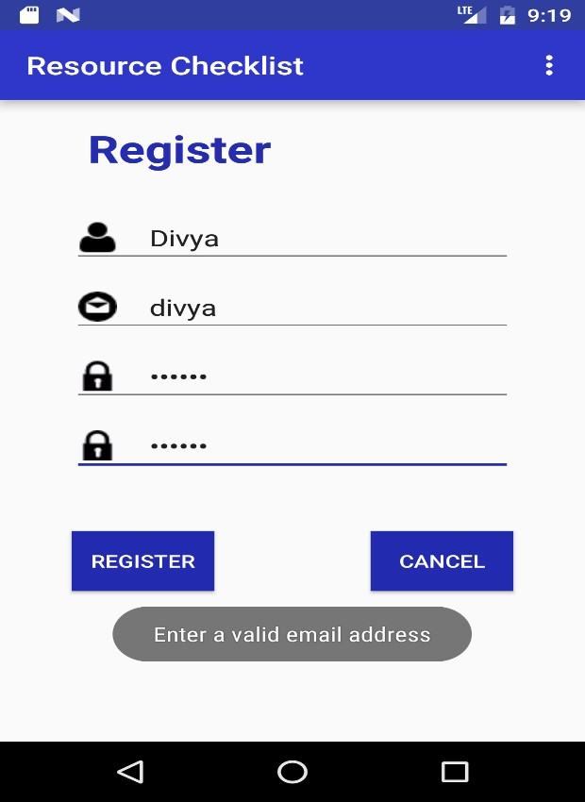

**Password mismatch:**

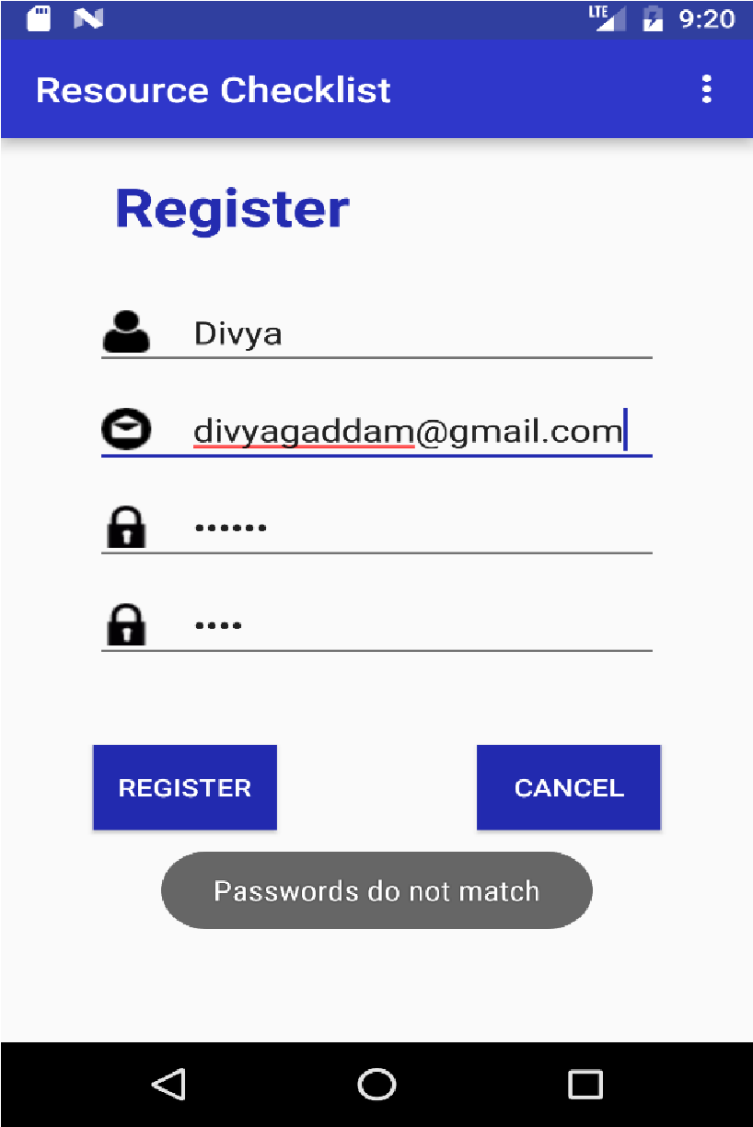

**Invalid password:**

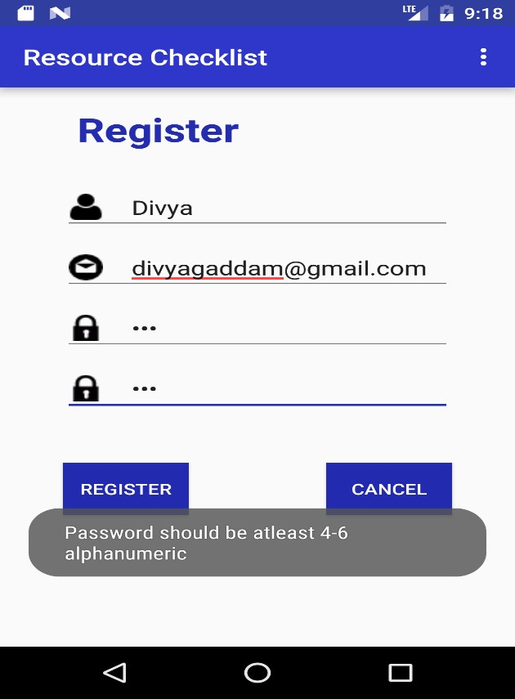

**Home Page:**

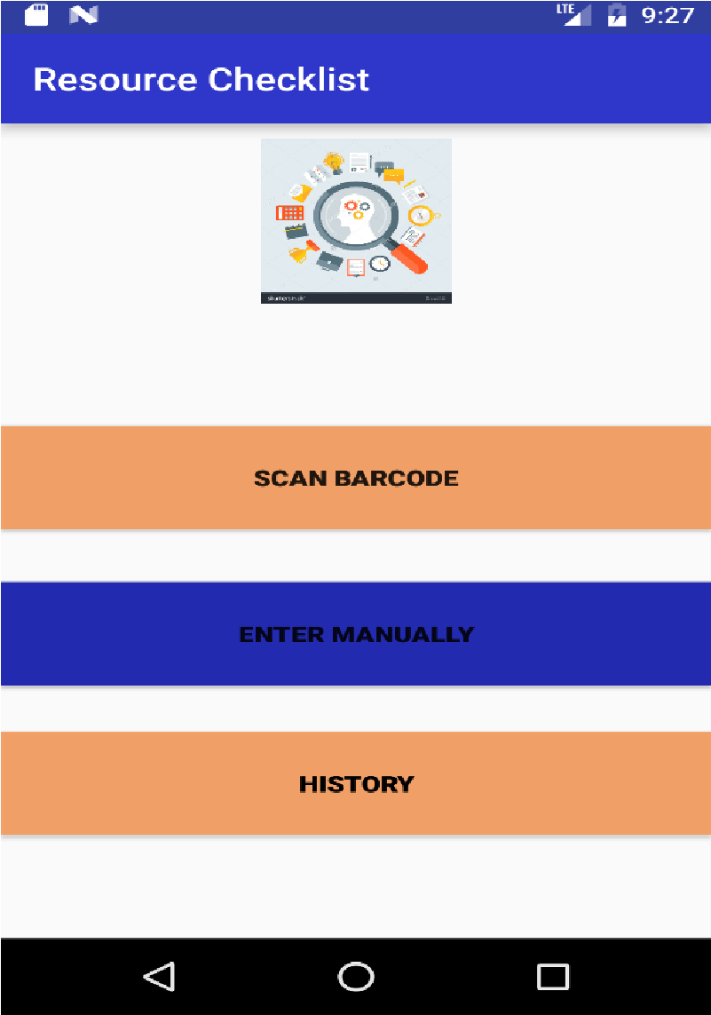

**SCAN ITEM:**

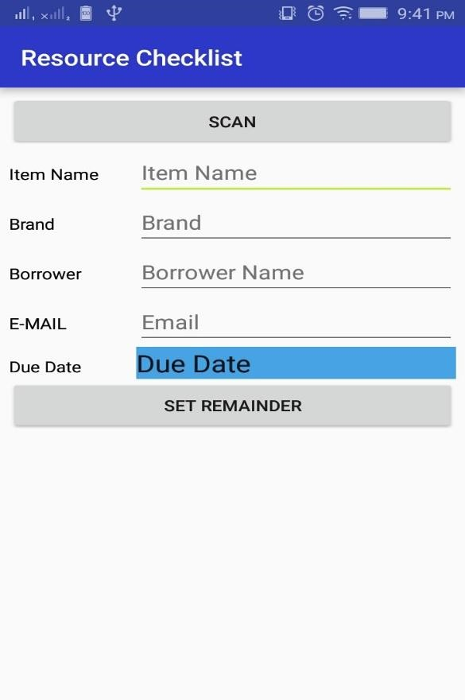

**Scanning Item:**

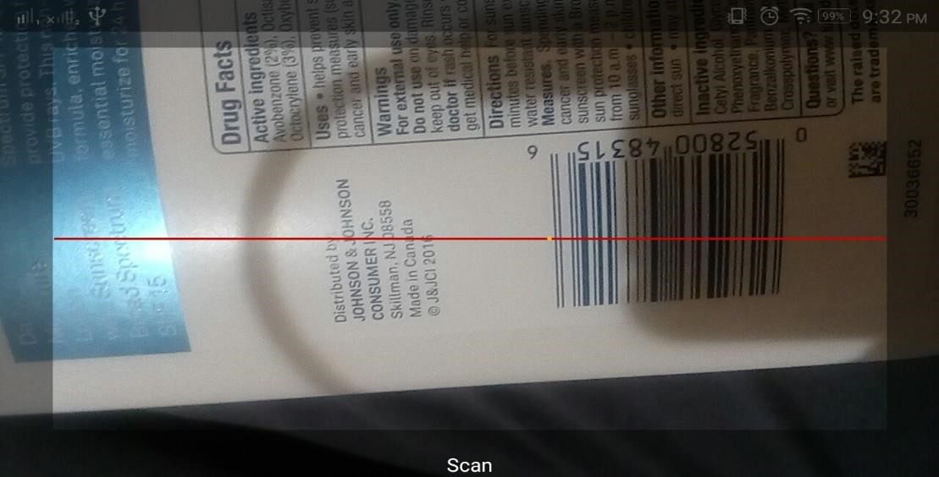

**Calendar option for due date:**

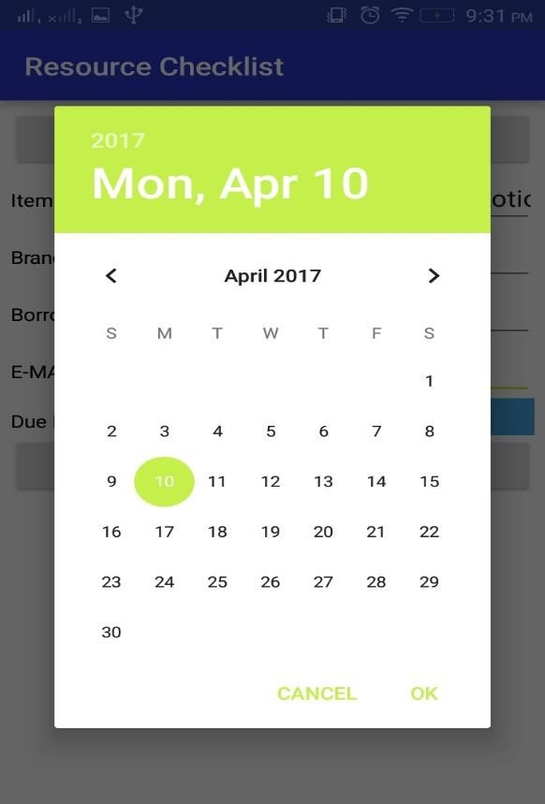

**Details are populated after scan:**

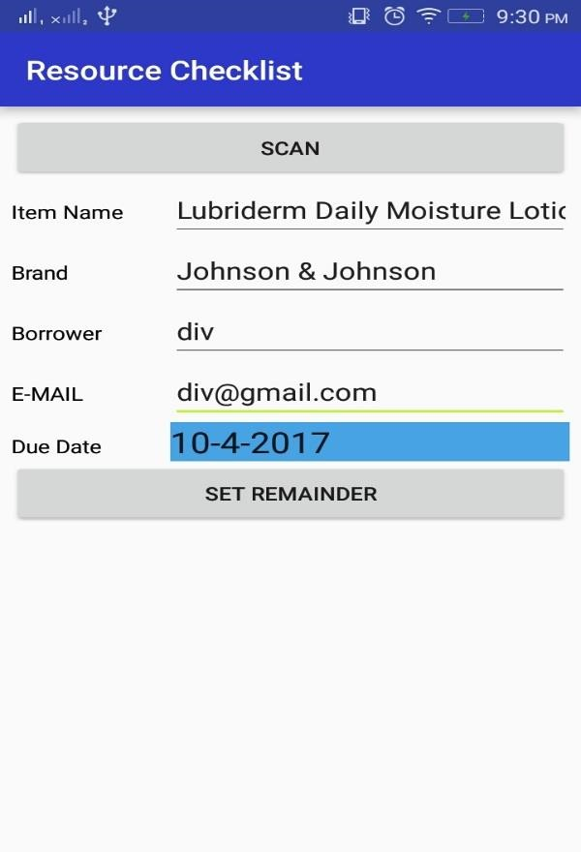

**HISTORY:**

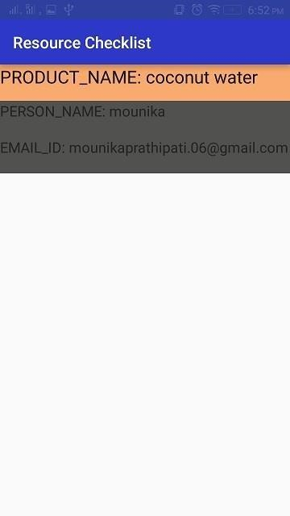

**Select an entry to send reminder:**

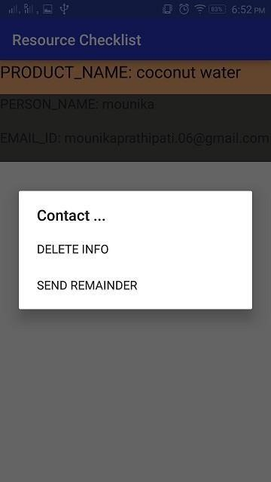

**Sending Reminder:**

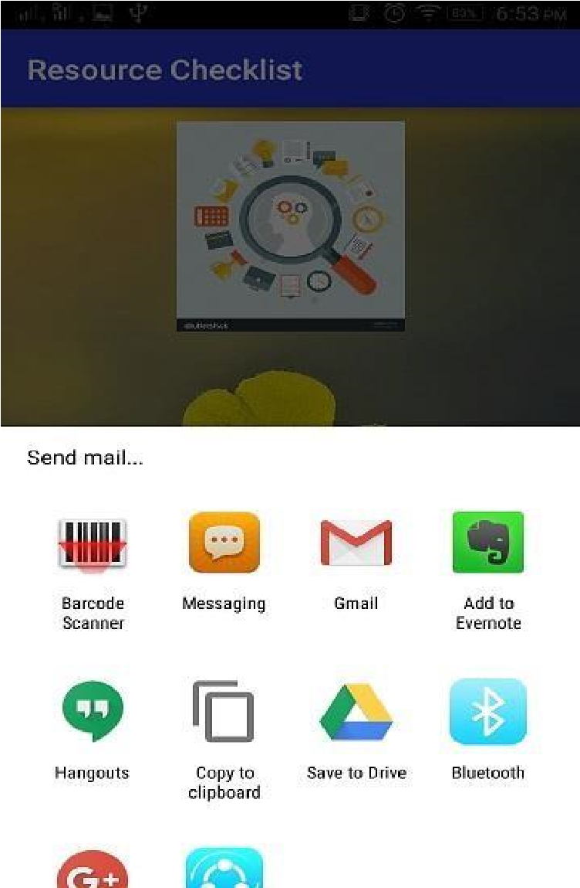

**Sending message:**

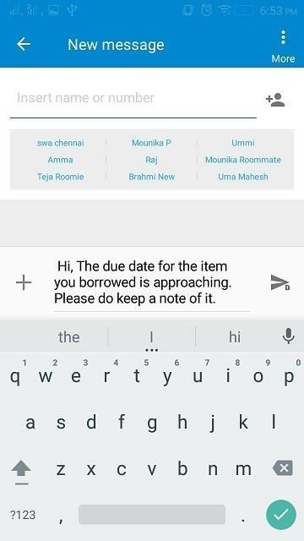

**Sending email:**

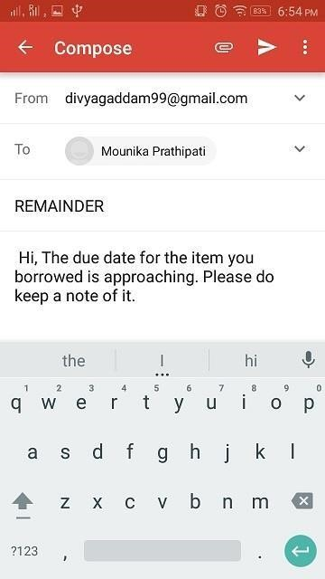

**Deployment:**

The “Resource Checklist” application has implemented in Android Studio onto an emulator of which screenshots are provided above.

**Project Management:**

**Implementation status Report:**

**Work Completed:**

* Manual entry of details Contributor – Swathi Jasthi

Time taken – 20 hours

Contribution – 25%

* Population of details automatically after Barcode scan

Contributor – Mounika Prathipati

Time taken – 20 hours

Contribution – 25%

* Automatic reminder

Contributor – Divya Gaddam

Time taken – 20 hours

Contribution – 25%

* UI enhancement

Contributor – Uma Maheswara Reddy Mandapati

Time taken – 20 hours

Contribution – 25%

**Work to be completed:**

* Object Detection

Contributor – Uma Maheshwara Reddy Mandapati, Divya Gaddam, Mounika

Prathipati

Estimated hours – 80hrs each

* UI enhancement

Contributor – Swathi Jasthi

Estimated hours – 80 hours

**Bibliography:**

<https://developers.google.com/maps/documentation/javascript/get-api-key><https://www.youtube.com/playlist?list=PL6gx4Cwl9DGBsvRxJJOzG4r4k_zLKrnxl><https://developer.android.com/training/basics/firstapp/creating-project.html><https://www.udacity.com/course/android-development-for-beginners--ud837>

[https://www.gliffy.com](https://www.gliffy.com/)[/ https://creately.com/](https://creately.com/)

<https://github.com/KeepSafe/android-resource-remover>



**Resource Checklist**

(Increment -4)

**By**

***Team Name – Decoders***

***Team No# 20***

Swathi Jasthi

Divya Gaddam

Mounika Prathipati

Uma Maheswara Reddy Mandapati

**COMP-SCI 5551 Adv Software Engineering**

**University of Missouri Kansas City**

**Spring – 2016**

**Contents**

**Project Goal and Objectives ........................................................................................ 2**

**Motivation .............................................................................................................. 3**

**Significance/Uniqueness ......................................................................................... 3**

**Objectives ............................................................................................................... 3**

**System Features ..................................................................................................... 4**

**Second Increment Report………………………………………………………………………………………….4**

**Existing Services/Rest API……………………………………………………………………………………...4**

**Detail Design Features…………………………………………………………………………………………...4**

**User stories……………………………………………………………………………………………………………….11**

**Testing……………………………………………………………………….…………………………………….……...14**

**Implementation……………………………………………………………………………………………..….….…15**

**Deployment……………………………………………………………………………………………………….…….24**

**Project Management………………………………………………………………………………………….…….24**

**Bibliography………………………………………………………………………………………………………….....25**

**Project Goal and Objectives:**

**Motivation:**

In today’s busy life, resource monitoring has become a big issue because of the growing work pressure and social pressure we may forget the things we had lent. I had a real-time experience with this kind of situation. I had lent a book to my friend which I found to be very motivational and interesting but I forgot to take it back. After few months, I thought of reading the book again and searched for it but I cannot find it. I was not able to recollect where I had kept the book or whom I had given to. After two years, when my friend was shifting home, he found the book in their store room and returned it to me asking apologies for the mistake. Most of my friends tell me that they faced a situation like this in their life. So, we thought that there is need to develop a resource management system for people. The application can be used for keeping record of the items being borrowed by individuals. As smart phones are becoming part of our lives, it is the best choice to deploy our resource management system.

**Objective:**

The application mainly aims at keeping track of various items such as books, tablets or any other devices either by a barcode scan or by taking a picture manually even by entering the current location of borrower. The scope of this application is that it can be used by anyone who wants to keep track of their belongings.

**Significance/Uniqueness:**

Although there are other applications which can remind you of the things which you have lent, our application differs from them because of the following features:

* The applications which are present currently can remind you just with the text which you had written for that reminder, but in our application, we had incorporated two new features as the user can associate a picture with it or he can have a bar code scan for the item which he is lending. The reminder in our application will show you that information also.
* In our application, a message (either a text message or an email) will be sent to both the lender and the borrower saying that the due date is approaching for the item. This will ensure better security.

**System Features:**

The resource monitoring app can be used to keep track of items. The system features include:

* Users can scan the item that they are lending, and then enter the details of the person whom they are lending it to.
* They can also store the information of the items that do not have a barcode, this can be done by taking the picture of the item manually and storing the details of the borrower.
* Send Email or text message to the borrower as a reminder
* Uses SQLite database for the implementation of storing the details
* All the details are stored in a List View format and can be viewed from history Delete the details when we get back the item.

**Second Increment Report:**

**Existing Services/REST API:**

**API’s Used:** Facebook Login API and Google API.

**Detail Design of Features:**

**Wireframes:**

**Login Page:**

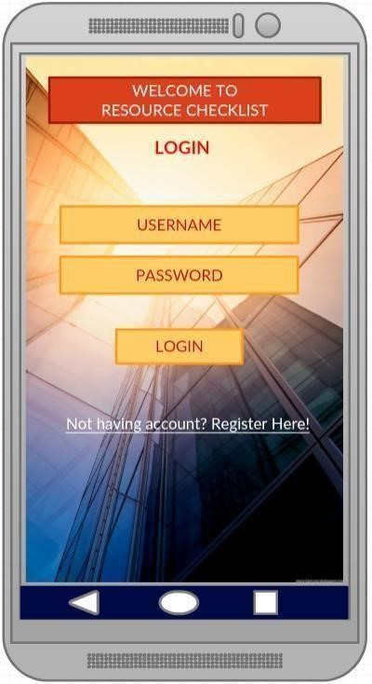

**Register Page:**

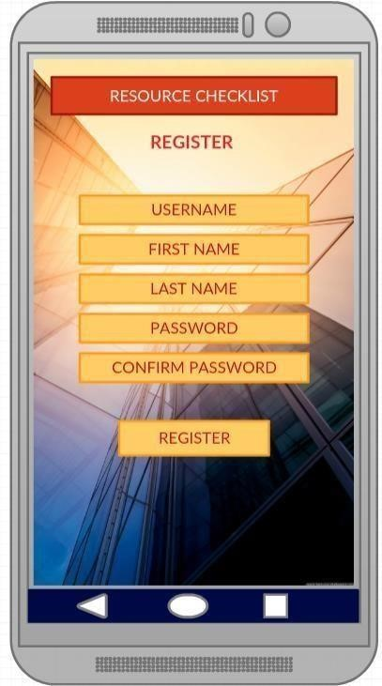

**Home Page:**

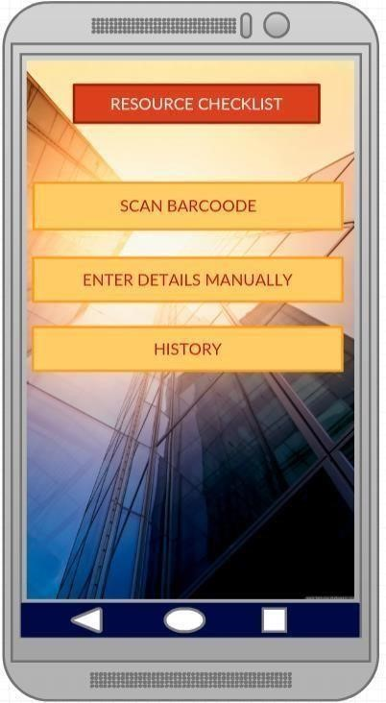

**Manual Entry:**

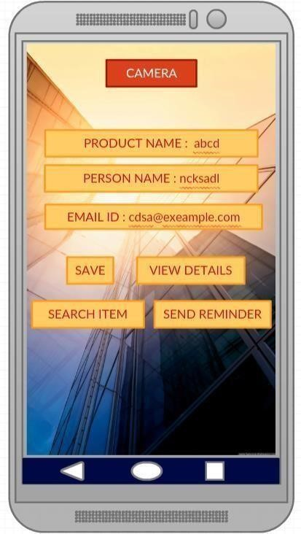

**Product Search:**

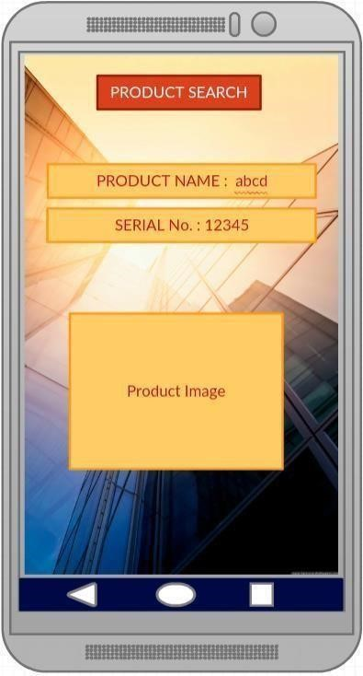

**Scan Item:**

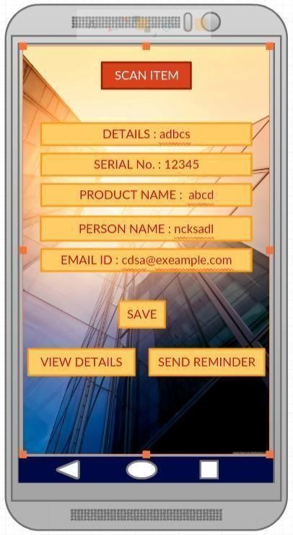

**History:**

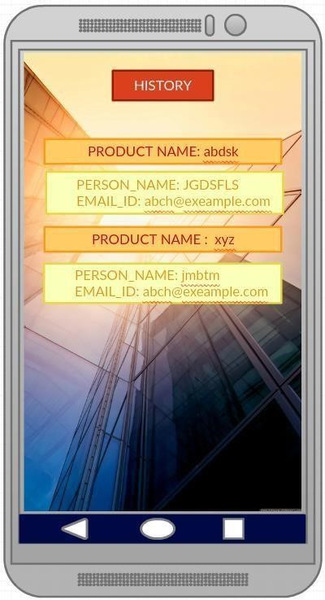

**Selecting an item from history:**

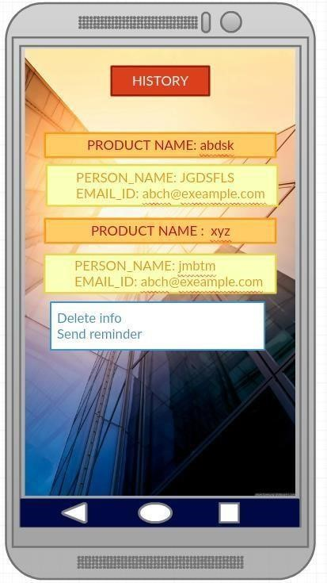

**Architecture Diagram:**

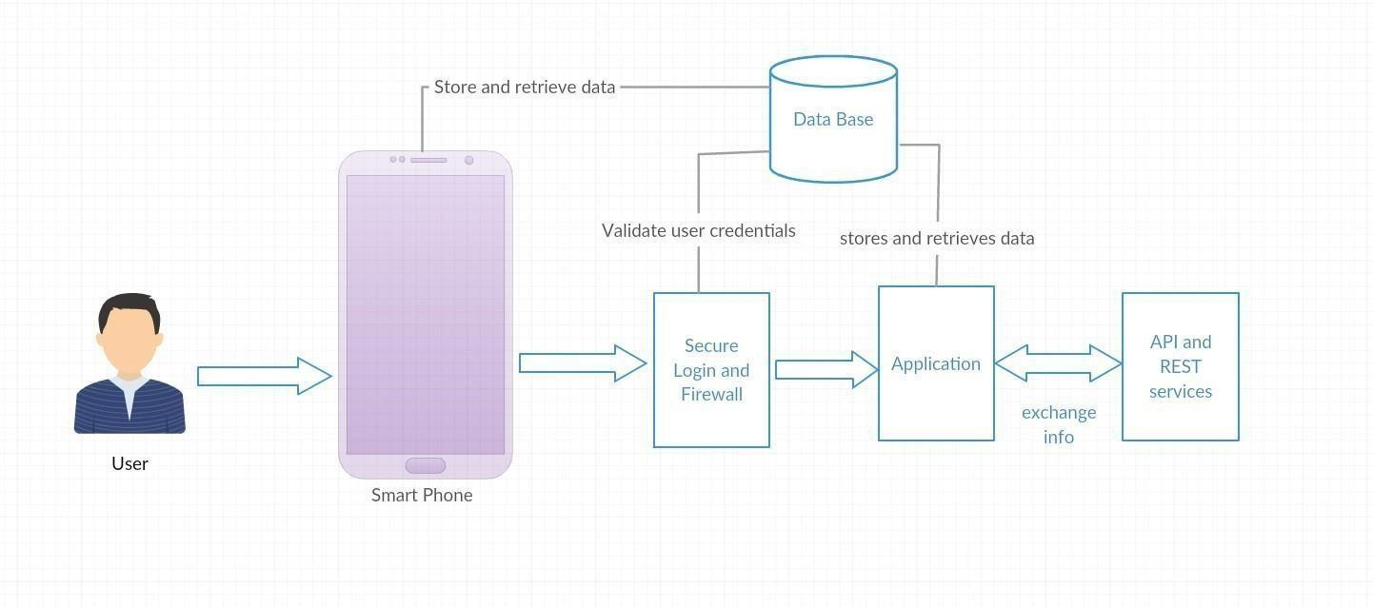

**Sequence Diagram:**

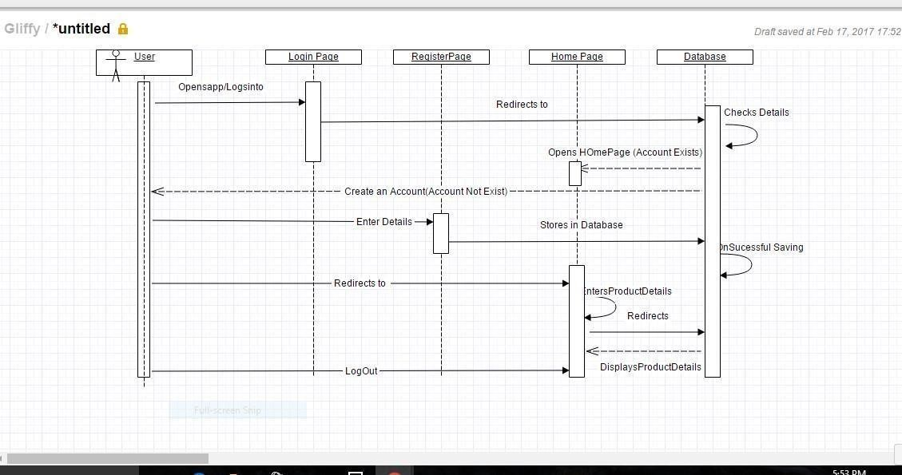

**Class Diagram:**

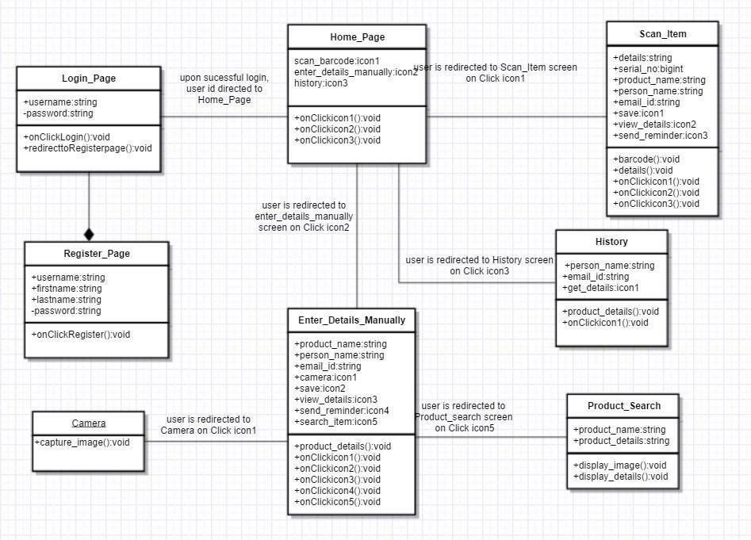

Page

**Use Case:**

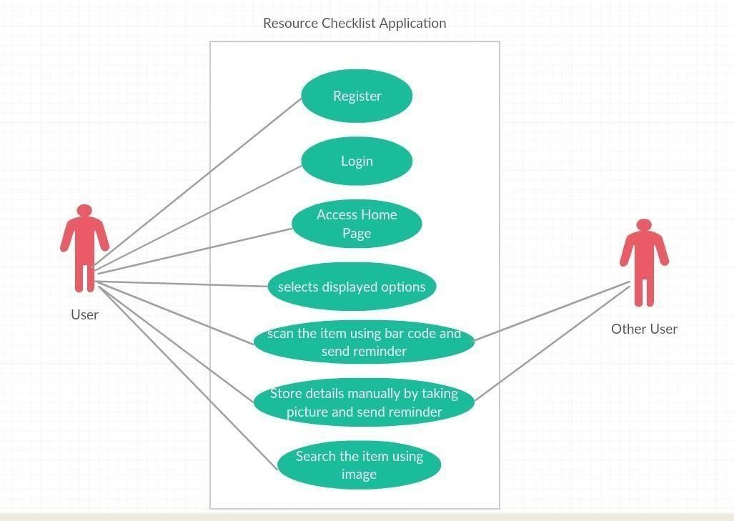

**User Stories:**

1. Plan the increments to create resource management application.
2. Finalize the project plan and document the revised project plan.
3. As a user, I should be able to login into the resource checklist application.
4. As a user, I should to have options to register to the application to use it.
5. The user should be redirected to the Home Page after a successful login.
6. The user should have two options to enter a product details. One is through Barcode scanning and the other is to enter the details manually.
7. Being a user I can scan the item through Barcode Scanner and able to add it to my database using SQLite to history.
8. Sending text message or Email to the corresponding borrower to remind him saying his due date is approaching.
9. Sending remainder to the person repeatedly from history by selecting the corresponding item.
10. I could be flexible in erasing item details from history if I do not want anymore.

**ISSUES:**

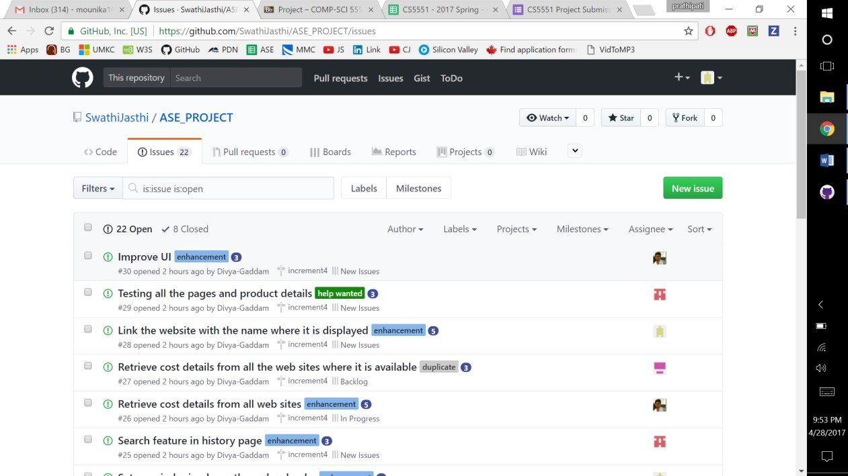

**BOARD:**

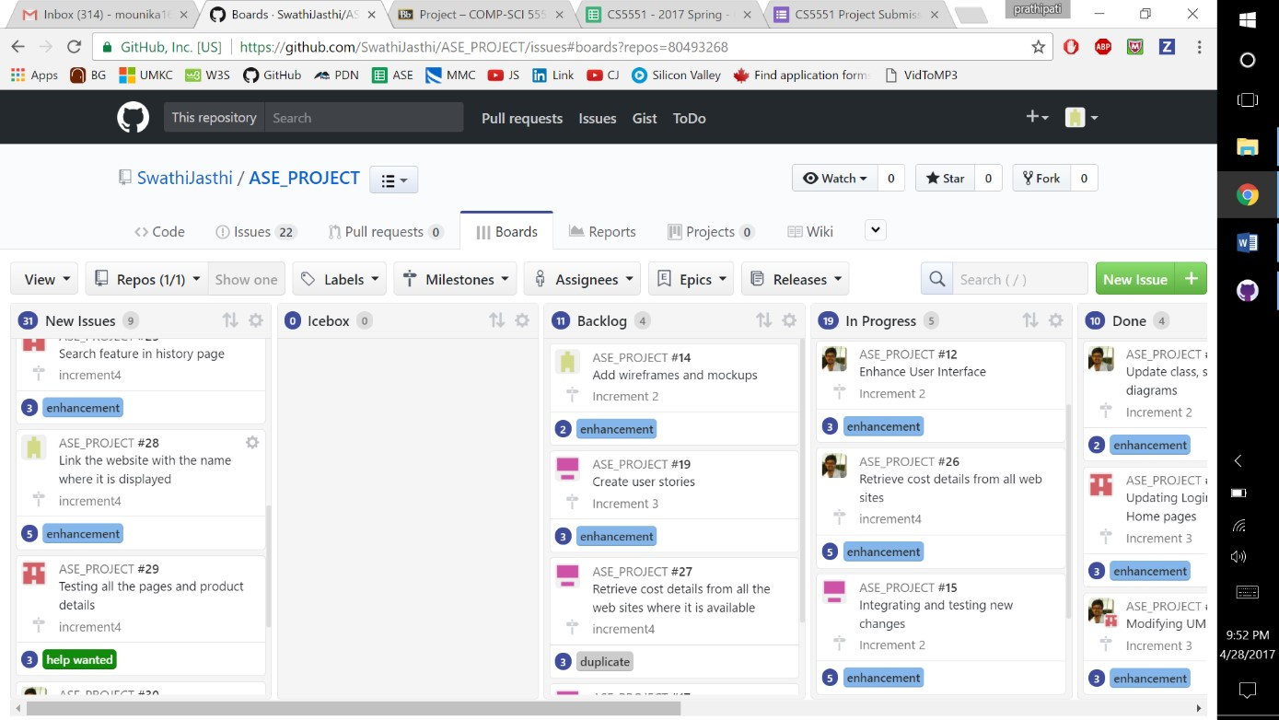

**BURNDOWN CHART:**

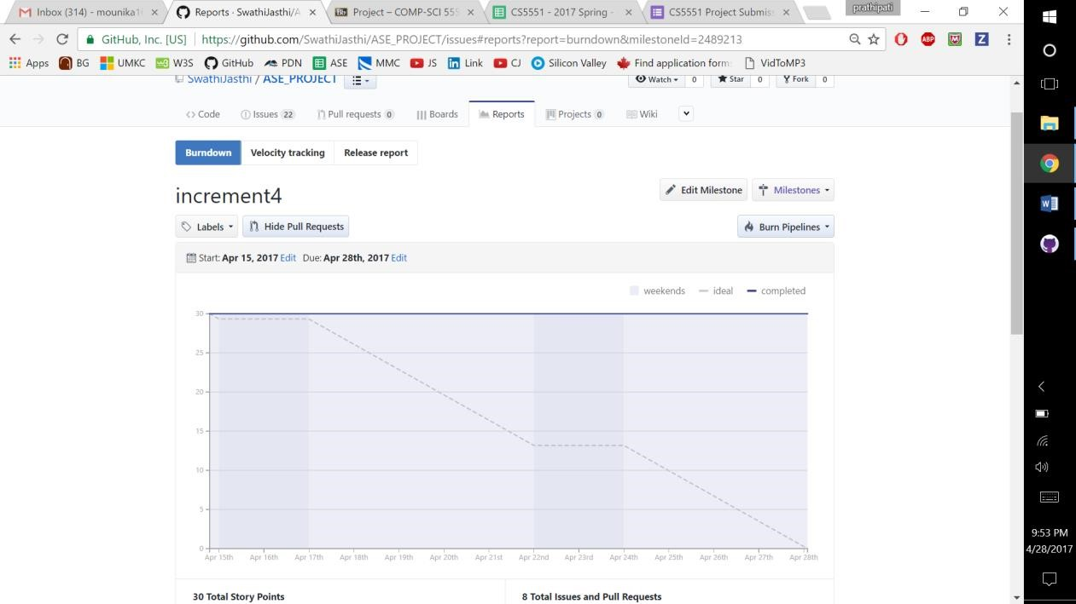

**Testing:**

**Unit Testing:**

|  |  |  |  |
| --- | --- | --- | --- |
| **User**  **Story**  **Number** | **Test Case Description** | **Expected Result** | **Test**  **Result** |
| **3** | **Enter invalid mail ID and valid password** | **Error message should come as “invalid credentials”** | **PASS** |
| **3** | **Enter valid mail ID and invalid password** | **Error message should be displayed as “invalid credentials”** | **PASS** |
| **3** | **Enter invalid mail ID and invalid password** | **Error message should come as “invalid credentials”** | **PASS** |
| **5** | **Enter valid mail ID and valid password** | **User is redirected to Homepage successfully** | **PASS** |
| **4** | **Enter a word without @gmail.com at the end of the string in email ID field** | **Error message should be displayed as “enter valid mail ID”** | **PASS** |
| **4** | **Enter a password with length less than 4 characters** | **Gives error message “password should have minimum of 5 characters”** | **PASS** |
| **4** | **Enter two different passwords in password field and confirm password field.** | **Gives error message “passwords do not match”** | **PASS** |
| **4** | **Enter all the fields in register page correctly** | **User is redirected to home page successfully** | **PASS** |
| **7** | **Scanning the item through Barcode**  **Scanner** | **Scanning the Barcode** | **PASS** |
| **7** | **Details are to be saved** | **Displaying the saved results** | **PASS** |
| **8** | **Sending the reminder to the corresponding person** | **Reminder sent** | **PASS** |
| **9** | **After Sending the reminder the details are to be saved** | **Details are saved and can view in history** | **PASS** |
| **10** | **Flexibility in clearing the unwanted data** | **Cleared the data** | **PASS** |

**Implementation:**

The “Resource Checklist” application has implemented in Android Studio onto an

Android mobile. Below screenshots describes the flow  **Login Page:**



**Invalid Credentials:**



**Registration Page:**



**Invalid email-id:**



**Password mismatch:**



**Invalid password:**



**Home Page:**

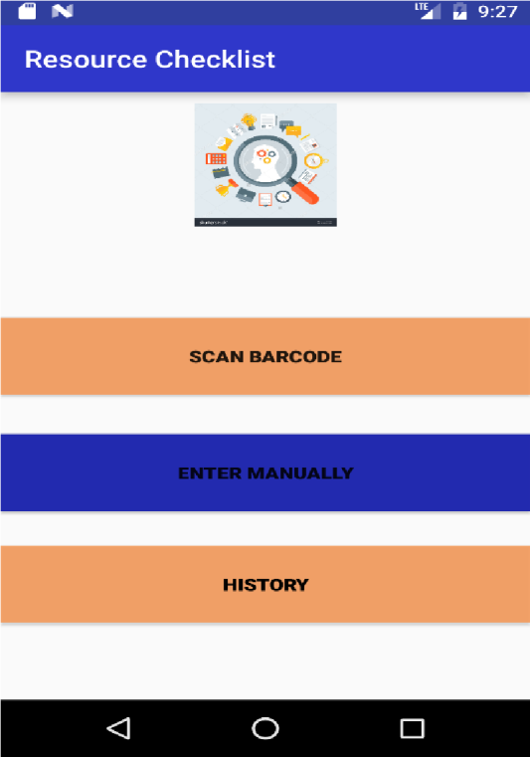

**SCAN ITEM:**

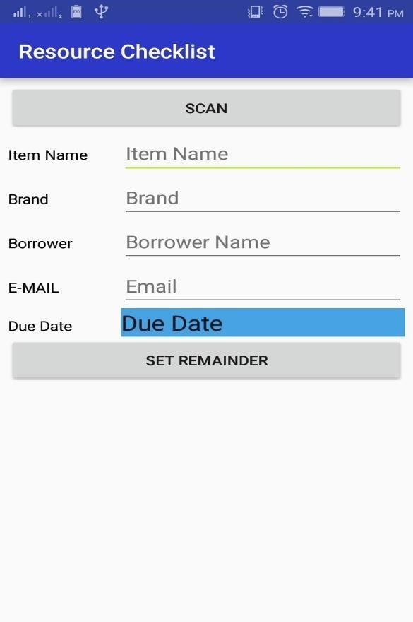

**Scanning Item:**



**Details are populated after scan:**



**Price Comparison:**



**Redirecting to website:**



**Scan Item 2:**

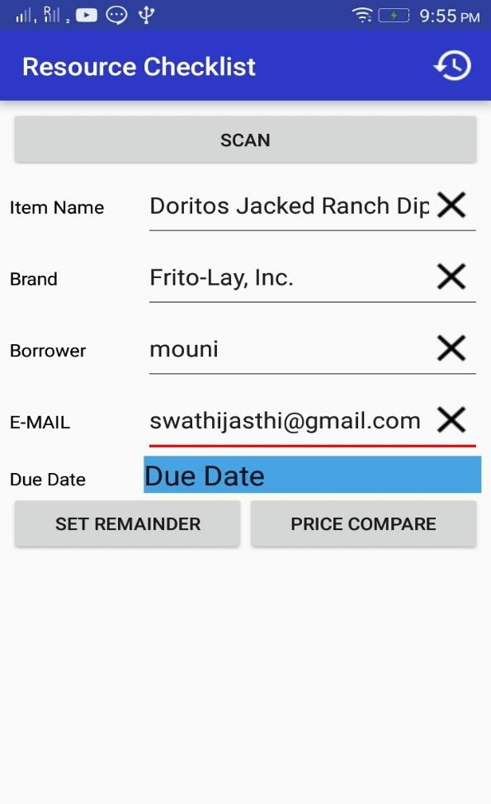

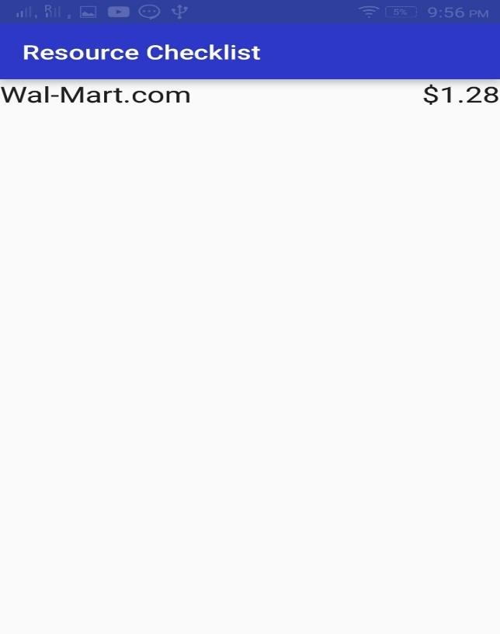

**Calendar option for due date:**



**HISTORY:**



**Select an entry to send reminder:**



**Sending Reminder:**



**Sending message:**



**Sending email:**



**Deployment:**

The “Resource Checklist” application has implemented in Android Studio onto an emulator of which screenshots are provided above.

**Project Management:**

**Implementation status Report:**

**Work Completed:**

API search and price comparison logic code contribution – Entire Team

* Manual entry of details

Contributor – Swathi Jasthi

Time taken – 20 hours

Contribution – 25%

* Population of details automatically after Barcode scan

Contributor – Mounika Prathipati

Time taken – 20 hours

Contribution – 25%

* Automatic reminder

Contributor – Divya Gaddam

Time taken – 20 hours

Contribution – 25%

* UI enhancement

Contributor – Uma Maheswara Reddy Mandapati

Time taken – 20 hours

Contribution – 25%

**Work to be completed:**

* UI enhancement

Contributor – Entire Team

Estimated hours – 80 hours

**Bibliography:**

<https://developers.google.com/maps/documentation/javascript/get-api-key>

<https://www.youtube.com/playlist?list=PL6gx4Cwl9DGBsvRxJJOzG4r4k_zLKrnxl><https://developer.android.com/training/basics/firstapp/creating-project.html><https://www.udacity.com/course/android-development-for-beginners--ud837>

[https://www.gliffy.co](https://www.gliffy.com/)[m/ https://creately.com/](https://creately.com/)

<https://github.com/KeepSafe/android-resource-remover>

**Project Presentation Slides:**



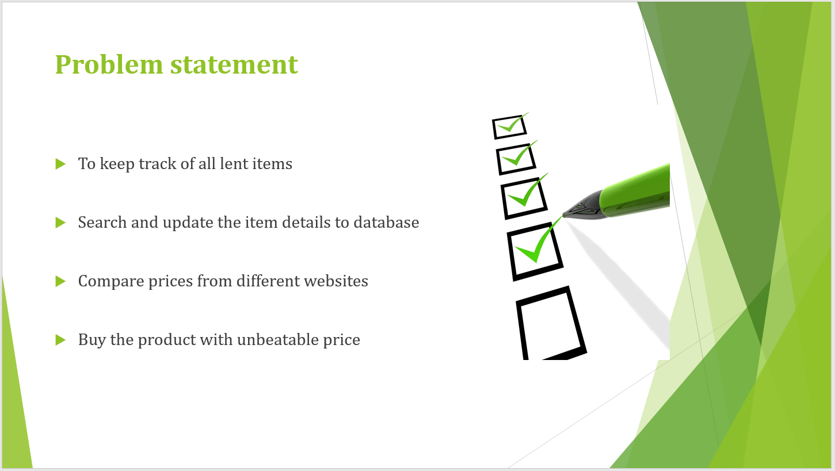

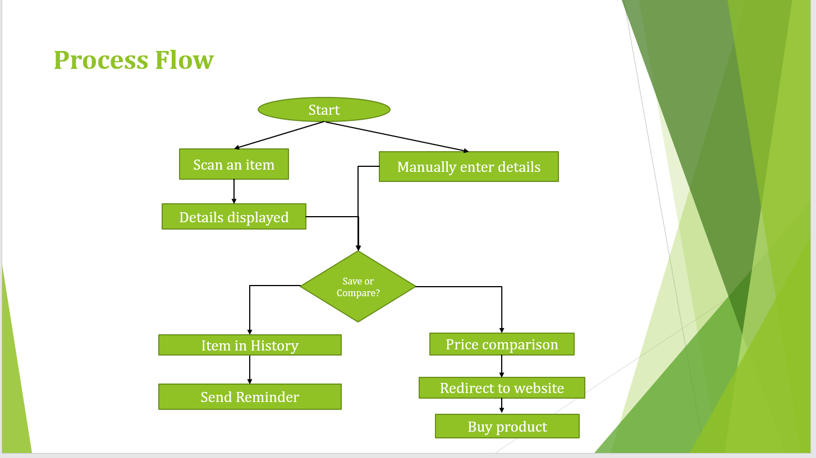

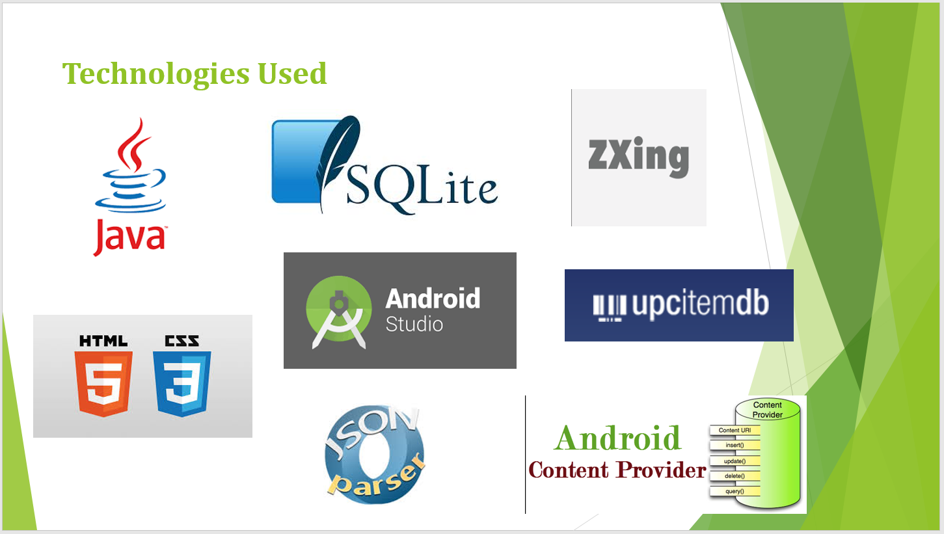

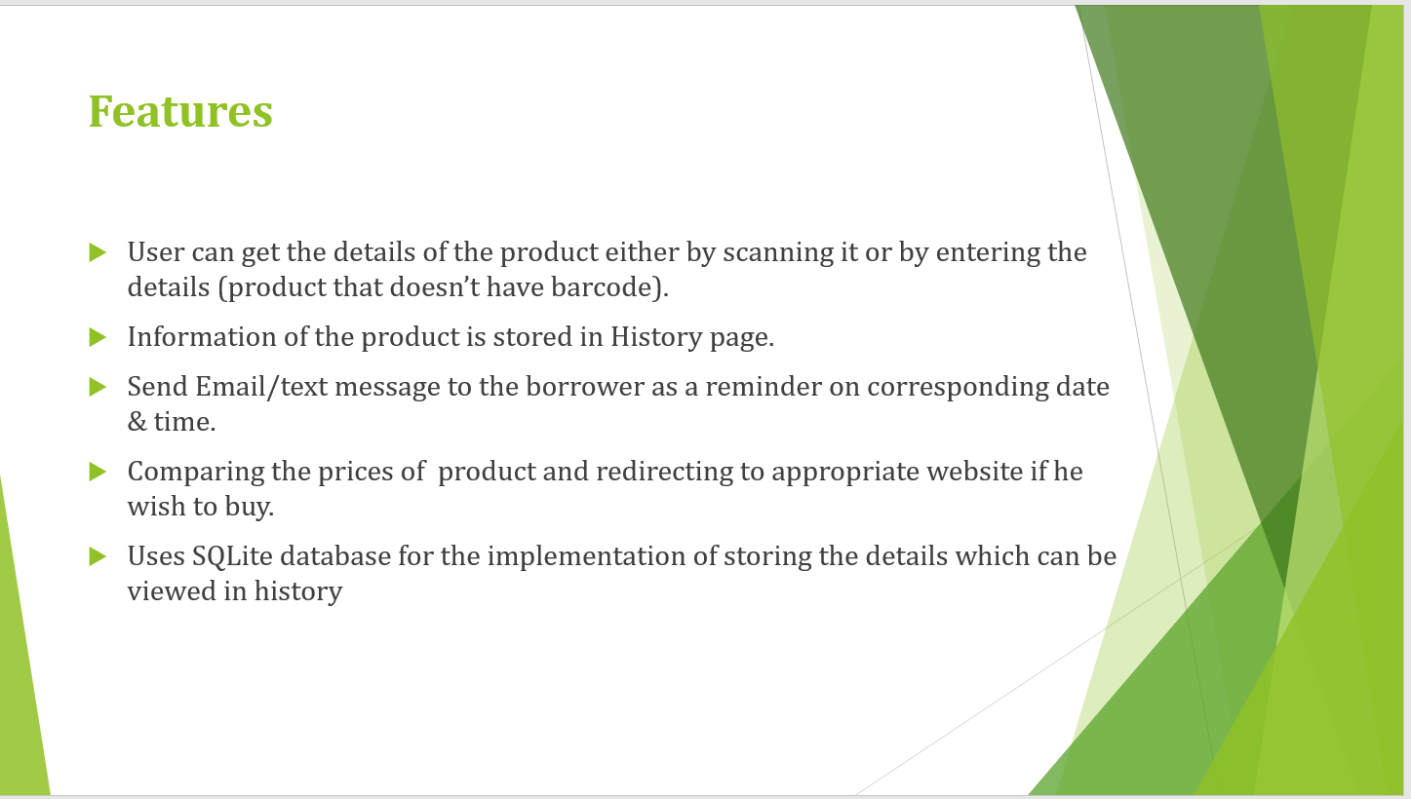

**GitHub URL for the final project:**

<https://github.com/SwathiJasthi/ASE_PROJECT/tree/master/Final%20project%20sourcecode>

**YouTube URL for project presentation Video:**

<https://www.youtube.com/watch?v=w3su7RaBFOk>